Spring Term 2017/2018

CandNo: 184516

Computing project

An Individual Computing Project

Monopoly

Contents

Statement of Originality 3

List of Tables 4

List of Illustrations 5

Annex 5

Introduction 6

How I Selected Monopoly 6

Program Language 7

Overall Objectives/Critical Path 7

Main Algorithms that will make up the game 7

My Approach 8

Overall Game Design 10

Rules and Criteria 10

Changes made 11

Simple Program 15

Introduction 15

Plan and Design 15

Objectives 15

Screen Design 16

My Approach 19

Class Diagram 20

Implementation 21

Testing 41

Test Plan 41

Test Log 44

Evaluation 49

The Graphic User Interface 52

Introduction 52

Plan 52

Objectives 52

Pygame Research 53

My Approach 53

Design 54

Designing My Board 54

Screen Design 57

Implementation 58

Objective 6: Rolling the dice 63

Testing 72

Test Plan 72

Test Log 75

Evaluation 89

The Computer Player GUI 92

Introduction 92

Plan 92

Objectives 92

My Approach 93

Implementation 94

Test Plan 97

Test Log 98

Evaluation 103

The Computer Player GUI 105

Introduction 105

Plan 105

Objectives 105

My Approach 106

Implementation 107

Test Plan 110

Test Log 111

Evaluation 116

Overall Evaluation 118

User Guide 120

How to open the python programs 120

How to install Pygame 120

References 123

Bibliography 124

Appendix 125

# Statement of Originality

This report is submitted as part requirement for the degree of Foundation Year in Computing Sciences at the University of Sussex. It is the product of my own labour except where indicated in the text. The report may be freely copied and distributed provided the source is acknowledged.

Signed ______________________________________

Date: 29th May 2018

## 

# List of Tables

Table 1: Project Gantt Chart 8

8

Table 2: Pricing – Candy Types 13

Table 3: Pricing - Companies 13

Table 4: Pricing - Temptations 14

Table 5: Pricing - Bills 14

Table 6: Functions in simple program 21

Table 7: Test Plan 41

Table 8: Test Log 44

Table 9: Functions in the GUI program 58

Table 10: Test Plan 72

Table 11: Test Log 75

Full Screen Tests 87

Table 12: Functions in the computer GUI program 107

Table 13: Computer GUI Test plan 110

Table 14: Computer GUI test log 111

# List of Illustrations

Illustration 1: The method I will use to complete my project 9

Illustration 2: Draft Paper Board Design 18

Illustration 3: Class Diagram 20

Illustration 4: Whole Board Design 55

Illustration 6: Screen 60

Illustration 7: Dice 63

Illustration 8: Landing on a square 67

Illustration 9: Yes/No buttons 69

Illustration 10: Dentist cards 71

Illustration 11: Full Screen Tests 87

# Annex

Draft Paper Board Design

Class Diagram

# Introduction

For my individual project I have decided to write a computer program based on the game of ‘Monopoly’ with some changes. My project is a programming based one, touching on skills gained mainly in program design and foundation programming, but also using basic skills learnt from other modules.

The aim of this project is to create a ‘Monopoly’ board game with my own twist. I am going to make the game from scratch, creating a game for 2-6 players with a basic python program then will go on to create it into a GUI. After this I will create a computer player that the users can play against.

All the programs should follow the rules and criteria of monopoly, with some alterations to make the game original. I am planning to make the theme of my Monopoly board candy related.

The game should be thoroughly validated and extremely user friendly as I am aiming my target age to be a little bit younger than the original board game (8+), to being 6+ as the theme is more suited to younger children and will be simplified.

## How I Selected Monopoly

My original idea was to produce a website for a friend who is looking to start an online business that deals with overseas students. However, when I started the project I realised I would have to rely on him a lot for the design and information for the website whereas I wanted to work more independently for this project so rejected this option.

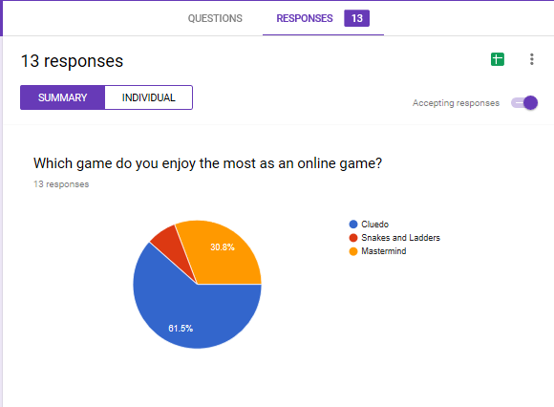

Therefore, I decided to do a game style project as I enjoy this area a lot and am quite interested in the design and programming part of the project. The three games that I was most interested in from my research was ‘Snakes and Ladders’, ‘Cluedo’ and ‘Mastermind’. I decided that the best way to find out which to do was to get some people around the target age of (8-16) and from my results opposite ‘Cluedo’ was the most popular choice.

However after I had planned, designed and started programming ‘Cluedo’, I realised that my python skills were insufficient as I was spending a lot of time trying to figure out how to represent the board. Therefore, I decided to choose a different board game with a simpler board structure but with a more difficult game play. Consequently, I thought that I would change my game to monopoly.

## Program Language

I have chosen to use Python as the language, as I have used Python before, however I will need to reteach myself as it was a while ago. I think this will work in my advantage as there are a lot of Python modules I can use and is also very user-friendly.

For the GUI part of the program I am going to use Pygame, which is a cross-platform set of Python modules which is designed for writing video games. It includes computer graphics and sound libraries designed to be used with the Python programming language. I will need to teach myself how to use these modules in Python as I have never used it before.

## Overall Objectives/Critical Path

1. Find the rules and criteria for the game
   1. The objective
   2. How to win
   3. Set up etc..
2. To design a board which is original and creative, along the lines of Monopoly
3. Create a simple program allows 2-6 players to play, that follows the rules and criteria of the game
4. Create the board for the graphic user interface
5. To research into Pygame, and use this information to help with creating the GUI
6. Create the graphic user interface
   1. Program so it is user friendly and easy to use
   2. Which shows the user the information they need
7. If there is time create a computer player
   1. Must follow the rules and criteria
   2. Correctly editing the basic program and then move on to updating the GUI
8. Test on users to get user feedback and make some changes

## Main Algorithms that will make up the game

1. My first will be to make a simple program, this will allow the users to play a 2-6 player game with the rules of Monopoly however it will not have a GUI, the users will be using python shell to play.
2. I will then design a GUI and use the simple program to allow 2-6 players to play the game by using the GUI, this game must also follow the rules of Monopoly.
3. I will then add in a computer player that will go through steps to try and win the game. I will change the GUI and the simple program slightly so the computer player algorithm will run and return moves

## My Approach

Below is the Gantt chart I have made to use throughout my project, for every separate program I will plan, program, test then evaluate. Along with some research of Pygame during the implementation, as well as most likely be researching into python.

#### Table 1: Project Gantt Chart

#### 

Illustration 1: The method I will use to complete my project:

Design

Analyse

For my simple 2-6 player text program

Analyse

Design

If incorrect

Implement

Test

For my 2-6 player GUI

If incorrect

Implement

Test

For computer player GUI

Analyse

Design

Implement

If incorrect

Test

Evaluate

## Overall Game Design

### Rules and Criteria

**Objective of the game:**

* To be the only player left in the game, when everyone has become bankrupt.

**Set up:**

* Each player is given £1500
* The cards must be placed faced down on the board
* Each player starts on the square ‘Go’

**How to play:**

* Current player rolls 2 dice
* Their token is moved around the board the number of spaces shown on the dice (added together)
* Player completes the actions on the square they have landed on (see below)
* If they go past go, they collect £200
* If a double was rolled, they get another go
* When they are finished, the dice is pasted to the next player

**Square**

* Unowned property
  + If landed on, this can be brought by the current player to the bank
* A colour square owned by another player
  + You must pay rent to the other player, rent depends on how many items they have on that square
* A temptationowned by another player
  + If the other player owns only one temptation, then you have to multiply the numbers on dice by 4 and that is the rent to be paid
  + If the other player owns both temptations, you have to multiply the numbers on the dice by 10 and pay this for the rent
* A card
  + Players receive a card and must follow the instructions
  + If the card = get out of jail free card, players keep it until they use it to be released from jail
* A bill
  + Players have to pay the amount shown
* Go to jail square
  + The player must move to the jail space immediately and the turn ends
    - 200 is not collected if they pass go
  + Players can also end up in jail from a card
* Free parking square
  + Players collect any money that is on that square
  + Collected from cards or bills
* When landing on go, just visiting or a property of your own nothing happens.

**How to get out of jail**

1. Pay £50
2. Use a get out of jail free card, that has been collected from the card pile
3. Roll a double

**Collecting rent**

* If another player lands on one of your properties, they must pay the rent

**Building**

* When you own a whole colour group you can start to buy items to place on the squares
  + The price depends on what colour you are on (further up the board is more expensive)
  + You must build evenly, cannot build a second item until all squares of this group have been built on
  + Once 4 small items are placed on each square you can upgrade to a bigger item
  + You can have maximum 4 small items on a square or max 1 big item

### Changes made

I am making my game candy themed; therefore I have to devise different square names, cards etc. I am also going to change the game slightly to simplify my program by ignoring the mortgaging and the deals between the players as I believe this will be too complicated to do in the amount of time I have.

**Basics**

1. **Monopoly Money 🡪 Candy coins/cc**
2. **There will be no banker**
3. **Adding houses/hotel 🡪 Adding sweet bags/tub**

**The board**

1. **Free Parking 🡪 Free Candy**
2. **Jail 🡪 Dentist**
3. **Tax 🡪 Bills/Tax**
   1. **Income tax 🡪 Sugar Tax**
   2. **Super tax 🡪 Medical Bill**
4. **Properties 🡪 Candy Types**
   1. **Brown 🡪 Light Pink**
      1. **Old Kent Road 🡪 Love hearts**
      2. **Whitechapel Road 🡪 Parma Violets**
   2. **Light Blue 🡪 Yellow**
      1. **The Angel Islington 🡪 Gummy bears**
      2. **Euston Road 🡪 Gum drops**
      3. **Pentonville Road 🡪 Wine Gums**
   3. **Pink 🡪 Dark Pink**
      1. **Pall Mall 🡪 Strawberry Laces**
      2. **Whitehall 🡪 Strawberry Pencils**
      3. **Northumberland Avenue 🡪 Rainbow Belts**
   4. **Orange 🡪 Light Blue**
      1. **Bow Street 🡪 Chewits**
      2. **Marlborough Street 🡪 Starbursts**
      3. **Vine Street 🡪 Fruit-tella**
   5. **Red 🡪 Green**
      1. **The Strand 🡪 Cola Bottles**
      2. **Fleet Street 🡪 Fizzy Cola Bottles**
      3. **Trafalgar Square 🡪 Fizzy Blue Bottles**
   6. **Yellow 🡪 Purple**
      1. **Leicester Square 🡪 Giant Strawberrys**
      2. **Coventry Street 🡪 Giant Cherries**
      3. **Piccadilly 🡪 Gummy Snakes**
   7. **Green 🡪 Orange**
      1. **Regent Street 🡪 Fox Glaciers**
      2. **Oxford Street 🡪 Humbugs**
      3. **Bond Street 🡪 Imperial Mints**
   8. **Dark Blue (stayed the same)**
      1. **Park Lane 🡪 Nerds**
      2. **Mayfair 🡪 Popping Candy**
5. **Stations 🡪 Companies**
   1. **Kings Cross 🡪 Maoams**
   2. **Marylebone 🡪 Haribos**
   3. **Fenchurch St Station 🡪 Chupa Chups**
   4. **Liverpool Street Station 🡪 Drumsticks**
6. Utilities 🡪 Temptations
   1. Electric Company 🡪 Candy Shop
   2. Water Works 🡪 Sweet Factory

**Chance and Community Chess Cards**

**Chance and Community Cards become only one type of card 🡪 Cotton Candy Cards, which include:**

1. **Braces bill, pay 100cc**
2. **Tooth fairy\'s came, collect 200cc**
3. **Get out of dentist free card**
4. **Advance to Go and collect 200cc**
5. **Buy the piñata for the party, pay 100cc**
6. **Cavity! Go to the dentist!**
7. **Take a trip to the Sweet Factory**
8. **You\'ve had a filling, pay 100cc**
9. **Sugar rush, advance 3 places**

**Simplifications**

1. **There will be no auctions**
2. **You cannot put a card up for mortgage**
3. **You cannot trade with other players**

**Pricing**

**All pricing is in candy coins/cc**

1. **Candy Types**
   1. **Blue = How much a player must pay to the player that owns the square if its empty/1 bag etc.**

#### **Table 2: Pricing – Candy Types**

|  |  |  |  |  |  |  |  |  |  |
| --- | --- | --- | --- | --- | --- | --- | --- | --- | --- |
| Square | Name | Price  Candy coins  (cc) | Empty | 1 bag | 2 bags | 3 bags | 4 bags | Tub | Price for 1 upgrade (bag/tub) |
| 2 | Love hearts | 60 | 2 | 10 | 20 | 90 | 160 | 250 | 50 |
| 4 | Parma violets | 60 | 2 | 10 | 20 | 90 | 160 | 250 | 50 |
| 7 | Gummy bears | 100 | 6 | 30 | 90 | 270 | 400 | 550 | 50 |
| 9 | Gum drops | 100 | 6 | 30 | 90 | 270 | 400 | 550 | 50 |
| 10 | Wine gums | 100 | 6 | 30 | 90 | 270 | 400 | 550 | 50 |
| 12 | Strawberry laces | 140 | 10 | 50 | 150 | 450 | 625 | 750 | 100 |
| 14 | Strawberry pencils | 140 | 10 | 50 | 150 | 450 | 625 | 750 | 100 |
| 15 | Rainbow belts | 140 | 10 | 50 | 150 | 450 | 625 | 750 | 100 |
| 17 | Chewits | 180 | 14 | 70 | 200 | 550 | 750 | 950 | 100 |
| 19 | Starbursts | 180 | 14 | 70 | 200 | 550 | 750 | 950 | 100 |
| 20 | Fruit-tell | 180 | 14 | 70 | 200 | 550 | 750 | 950 | 100 |
| 22 | Cola bottles | 220 | 18 | 90 | 250 | 700 | 875 | 1050 | 150 |
| 24 | Fizzy cola bottles | 220 | 18 | 90 | 250 | 700 | 875 | 1050 | 150 |
| 25 | Fizzy blue bottles | 220 | 18 | 90 | 250 | 700 | 875 | 1050 | 150 |
| 27 | Giant strawberries | 260 | 22 | 110 | 330 | 800 | 975 | 1150 | 150 |
| 28 | Giant cherries | 260 | 22 | 110 | 330 | 800 | 975 | 1150 | 150 |
| 30 | Gummy snakes | 260 | 22 | 110 | 330 | 800 | 975 | 1150 | 150 |
| 32 | Fox glaciers | 300 | 26 | 130 | 390 | 900 | 1100 | 1275 | 200 |
| 33 | Humbugs | 300 | 26 | 130 | 390 | 900 | 1100 | 1275 | 200 |
| 35 | Imperial Mints | 300 | 26 | 130 | 390 | 900 | 1100 | 1275 | 200 |
| 38 | Nerds | 350 | 35 | 175 | 500 | 1100 | 1300 | 1500 | 200 |
| 40 | Popping candy | 350 | 35 | 175 | 500 | 1100 | 1300 | 1500 | 200 |

1. **Companies**
   1. **Blue = How much a player must pay to the player that owns the square if it owns 1/2/3/4 of the companies**

#### **Table 3: Pricing - Companies**

|  |  |  |  |  |  |  |
| --- | --- | --- | --- | --- | --- | --- |
| **Square** | **Name** | **Price**  **(cc)** | **1 owned** | **2 owned** | **3 owned** | **4 owned** |
| 6 | Haribo | 200 | 25 | 50 | 100 | 200 |
| 16 | Maoams | 200 | 25 | 50 | 100 | 200 |
| 26 | Chupa Chups | 200 | 25 | 50 | 100 | 200 |
| 36 | Drumsticks | 200 | 25 | 50 | 100 | 200 |

1. **Temptations**
   1. **Blue = How much a player must pay to the player that owns the square if it owns 1 or both temptations**

#### **Table 4: Pricing - Temptations**

|  |  |  |  |  |
| --- | --- | --- | --- | --- |
| **Square** | **Name** | **Price**  **(cc)** | **1 owned** | **Both owned** |
| 13 | Sweet Factory | 150 | 4 x amount shown on the dice | 10 x amount shown on the dice |
| 29 | Candy Shop | 150 | 4 x amount shown on the dice | 10 x amount shown on the dice |

1. **Bills**

#### **Table 5: Pricing - Bills**

|  |  |  |
| --- | --- | --- |
| **Square** | **Name** | **If landed on** |
| 5 | Sugar tax | 100 cc |
| 39 | Medical bill | 100 cc |

1. The money under the free candy is made when people…
2. Pay the bills
3. Pay to get out of jail
4. And collected when a player lands on the Free Candy Square

# Simple Program

## Introduction

In this program I am going to create the game of Monopoly, without the GUI, in an object orientated programming manner. I have chosen to do it this way as it will be easier to maintain as I can easily modify the code and there will be less repetition. This program will follow the rules of monopoly with a twist in the design, I am going to make a couple of simplifications as I have not programmed in a while and I think will be too difficult to complete. I will use a board designed on paper please see Annex 1: Draft Paper Board Design to help me visualise the program. After I have finished the simple program, I will go on to create the GUI.

## Plan and Design

I am going to plan how to set out the board and find a way to represent the board in python. Write a simple program that concedes with the rules and criteria, sticking to the objectives during implementation. I will use my draft paper board to test and evaluate my program.

### Objectives

1. An original board needs to be created and be able to be represented in python
2. The program can only have 2-6 players that start the game with 1500 candy coins
3. Each player has a counter that must be able to move around the board by the total number of 2 dice
   1. If they get a double, after their first go, they get to roll again
4. When the player passes go, they must collect 200 cc
5. When they land on a square the particular action must occur
   1. If they land on a cotton candy card, they are given a card from random and the action on the card takes place
   2. If they land on free candy, they receive all the money under free parking
   3. If they land on bills, they must pay the amount shown on the square
   4. If they land on go to the dentist, they must be sent to the dentist
   5. If the square is free to be bought, they are asked if they would like to buy it
6. Once one player has all the candies of a particular colour, they must be asked if they would like to add any bugs or tubs to the square
   1. Can only add one bag/tub at time
   2. Each square with that colour must have the equal number of bags belonging to it before another is added
   3. Once they have 4 bags on each square, a tub can be added
   4. Once there is one tub on each square of the colour, there can be no more added
7. If a player lands on a square belonging to another player, that player must pay the other player the specific rent for that square
8. If a player has been sent to the dentist, the next go they get 3 options to try and be released
   1. Pay 50 cc
   2. Rolled a double
   3. Use a get out of the dentist free card (if owned)
   4. After they have chosen a correct option, the game moves on to the next player
9. Every time the program is run, it must check if a player has gone bankrupt (therefore misses a go), and if there is a winner (the rest of the players are bankrupt).

### 

### Screen Design

Key:

* !!! 🡪 programs output
* ??? 🡪 users input
* *Font* 🡪 scenarios
* Font 🡪 output to the user

How many players are there? ???

Each player starts with 1500 candy coins

Player 1, roll the dice: ???

Dice 1 = !!!

Dice 2 = !!!

You have landed on !!!!!!

Players banks = [!!!!, !!!!, …..]

*If the square can be brought:*  
The price of !!!!! is !!! cc

Would you like to buy it? ???

*If landed on a square that is owned by another player*

The number if bags on !!! is !!!

Therefore you have to pay !!! cc

*If there is a double:*

You have rolled a double, therefore you get another turn!

*If they land on free candy:*

You have landed on Free Candy

Free Candy, you have collected !!!! candy coins!

*If they land on go to the dentist:*

You have been sent to the dentist

Player !!!, please roll the dice(<ENTER>)

*If they land on a cotton candy card:*

You have landed on Cotton Candy Card

Your card = !!!!!!!!!

*Past Go*

Gone past go, you have collected 200 candy coins!

You have landed on !!!

*If the current player is in the dentist:*

Player 2, you are in the dentist, pick an option:

1. Pay 50cc
2. Try roll a double
3. Used a get out of dentist free card

Please enter your option: ???

You have !!!!! and are now released from the dentist!

*When a player can add a bag to one of their groups*

Player !!! would you like to add any bags to your squares? ???

*(if yes)*

Option 1: !!!!!!!!!!!! (names of candy squares)

Option 2: !!!!!!!!!!!!

Option 3: !!!!!!!!!!!! ……

Which option would you like to choose: ???

For !!! cc you have added a bag/tub to your square

*When a player has gone bankrupt*

Player !!! has gone bankrupt! Therefore are out of the game!

*When a player has won the game*

Player !!! you have won the game!

For my simple without the GUI I will be referring to the board I have made which is seen below and is attached as an annex to this document.

Illustration 2: Draft Paper Board Design

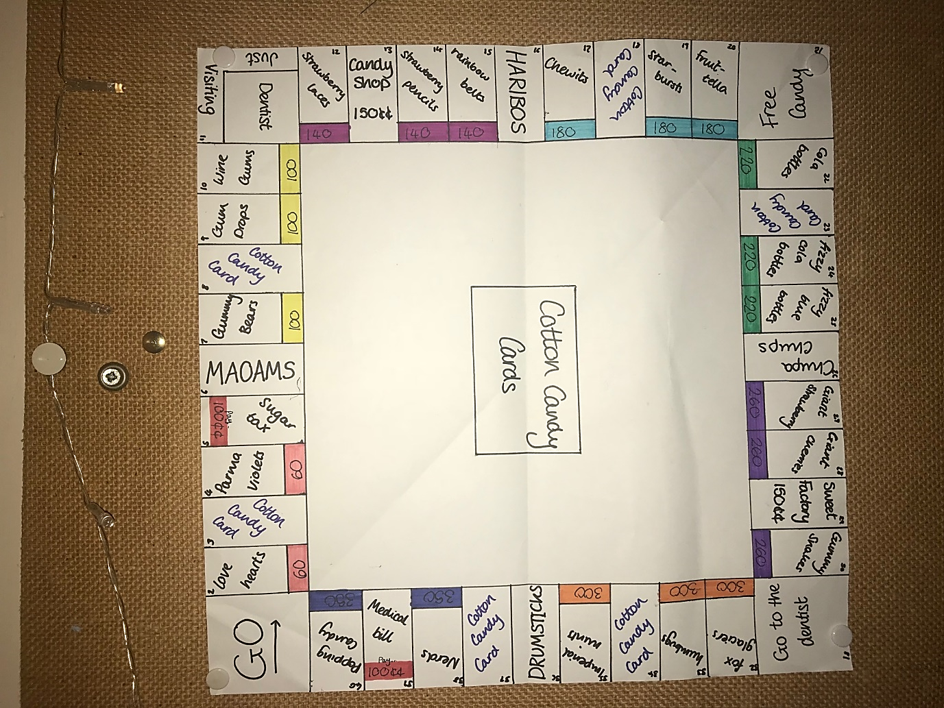

### My Approach

Throughout my approach there will be validation in places so there are little/no errors.

At the start:

1. Asks for number of players
2. Sets money in the banks

For each turn:

1. Has the game been won?
2. Is player at the dentist
   1. Yes = give options to be releases
   2. Moves on to next player
3. Checks if can add counter
   1. Yes = ask to add counter
4. Roll dice
5. Move that number of places
6. If landed on:
   1. Candy square
      1. Empty = Ask if player would like to buy
      2. Pay the player that owns it the correct amount of money
         1. Depends on how many bags/tubs there are
   2. Candy card
      1. Output to the user the card
      2. Carry out the action
   3. Bills
      1. Player has to pay the bills
   4. Temptation
      1. Empty = ask player if would like to buy
      2. Pay the player the correct amount of money
         1. If owns 1 = 4x dice roll
         2. If owns 2 = 10x dice roll
   5. Company
      1. Empty = ask player if would like to buy
      2. Pay the player that owns the correct amount of money
         1. Depends on how many companies they own in total
   6. Free candy
      1. Collect the money
   7. Just visiting dentist and go
      1. Nothing
   8. Go to the dentist
      1. Sends player to dentist, turn is over
7. Has player gone bankrupt
   1. Yes = player is out of the game
8. If player rolled a double
   1. Yes = get another go

### Class Diagram

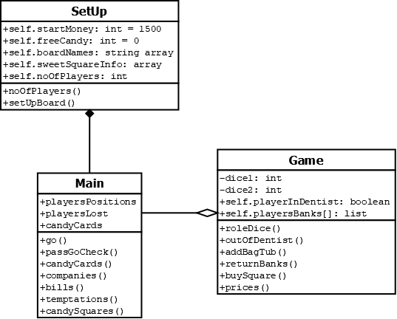Illustration 3: Class Diagram

## 

## Implementation

##### Functions in the simple program

I will add to this list whilst creating my simple program as I will add in data items as I go along.

#### Table 6: Functions in simple program

|  |  |  |
| --- | --- | --- |
| Name | Which class | Why is it used/what is returned(if anything) |
| players | SetUp | Asks the users to enter the number of players between 2 and 6, and returns the noOfPlayers |
| isPlayerInt | SetUp | Validates the users input for noOfPlayers |
| money | SetUP | Outputs to the screen how much money each player starts with |
| go | Main | Is the main loop which links most of the functions, whenever a player takes a turn this function runs |
| rollDice | Game | Rolls 2 dice using random.randint() which is outputted to the user, returns if it is a double and the total of the two dice |
| pastGoCheck | Main | Checks if the user has gone the whole way around the board, if they have they get 200cc |
| candyCards | Main | When a player lands on the cotton candy card square, a random card is given to them and the appropriate action is taken |
| squares | Main | When a player lands on a new square this function runs, and goes to the correct function that relates to that square |
| bills | Main | Makes the player pays the bills of 100cc |
| buySquare | Main | Asks the user if they want to buy that current square, if they don’t it returns to the previous function, if they do they pay the price |
| temptations | Main | If the current temptation is empty it goes to buySquare, however if it is owned by another player, it calculates the price the current player has to pay to the other player and updates the players banks |
| companies | Main | If the current company is empty it goes to buySquare, if its owned by another player the price is calculated that the current player has to pay the player who owns that square and the banks are updates |
| candySquares | Main | If the current square is empty it goes to buySquare, if brought, the candy squares information is updated. If the current square is owned by another player, the price that the current player pays the other is calculated by look at how many bags/tubs are on that square |
| addBagsTubs | Main | Checks if the player can add any bags or tubs onto one of their squares, if they can they give them the option for which square it is, if it is valid a bag/tub is added onto a square |
| dentist | Main | If the player is in dentist on their current go, this function runs. It asks the user to pick an option out of: paying 50cc, attempting to roll a double and using a get out of dentist free card. If they pick the first option, their bank will be updated, if they pick a second they roll a dice, if it is a double they are released, if not they stay in there for another go and if they pick the third option, if valid they are released, if not they get to choose again. |
| checkIfInt | Main | Checks if the option chosen from the dentist is valid |

##### Objective 1: Representing the board

An original board needs to be created and be able to be represented in python.

The information that needs to be represented by the board is:

1. The name of the square
2. The position

Therefore, I thought it would be best to represent it in an array, containing the names of the squares in order, therefore we could relate the positions by their number in the list:

e.g. self.board[14-1] = ‘Strawberry Pencils’

We subtract 1 as the arrays first position is at 0 and on our board numbers we have represented them with the first position at 1.

Below is how I represented my board in python:

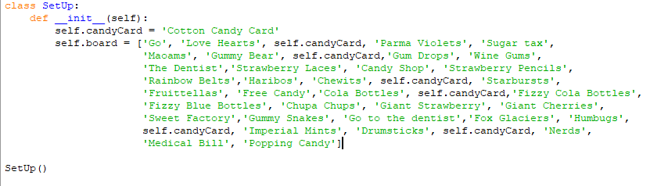

I used another variable ‘candyCard’, to represent all the cotton candy cards as if I were to change the name of the card, I would only have to chance it once.

##### Objective 2: Setting up the game

The program can only have 2-6 players that start with 1500cc

I decided to ask the users for how many players they would like, and automatically set the users start banks to 1500cc and assigned it to every user.

Asking for players:

* Can only have between 2 to 6 players
* Has to be an integer returned

To see if it were an integer that was given, I looked up how to see if a variable was an integer or a string, I tried using this line of code:

isinstance(<var>, int)

**REFERENCE HERE**

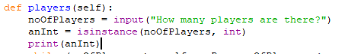

Therefore if it was an int, anInt would equal True, if not it would equal false.

However, when I tested it, whatever the variable type it returned False:

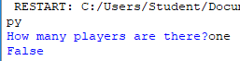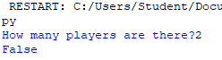

To solve this I tried another option, which was a try and except statement. I decided to do this in a separate function so it is clearer and easier to change (isPlayerInt). When ensuring the number of players is between 2 and 6, I used a while loop with the < and > operators. If it was incorrect an error message would appear, if correct the noOfPlayers would be accepted and returned.

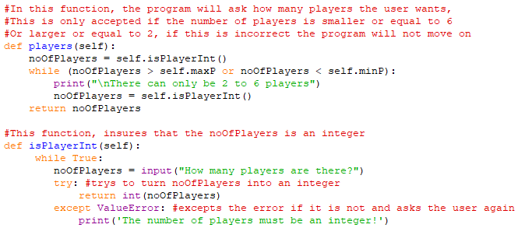

Example of testing:

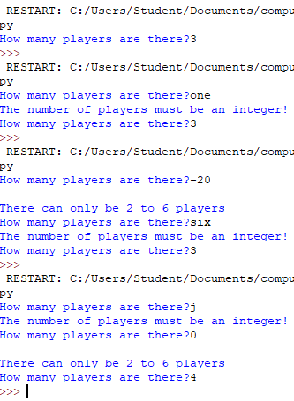

All players start off with 1500cc, therefore in the initializing function I decided to append the start money to an array called playersBanks which will change throughout the game. Then also have another function (money) which outputs the start money to the users.

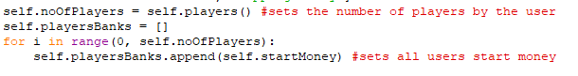

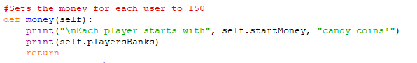

Example of testing:

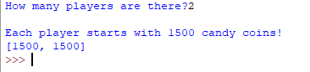

##### Objective 3: Moving around the board

Each player has a counter that must be able to move around the board by the total number of 2 dice

1. If they get a double, after their first go, the get to roll again

I made a new class named ‘Game’ as well as another class called ‘Main’. I used the random python library which is a module that implements pseudo-random number generators.

I created a new variable called ‘playersPlaces’, which is initialised in the class ‘SetUp’, where at the beginning of the program each player place is set to 1 (GO). This array will change to the new position every time the players move around the board.

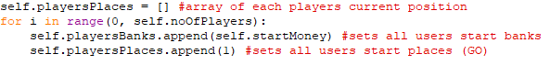

The ‘Main’ class inherits ‘SetUp’ therefore when main is called all of the set up (players banks, places etc.) are initiated.

In the main class, the function dice is called every turn, where the dice is calculated at random and tested to see if it is a double. If the dice is a double the player gets another go, if not, the game moves on to the next player. When a player completes an entire loop round the board, the position needs to be set back to 1.

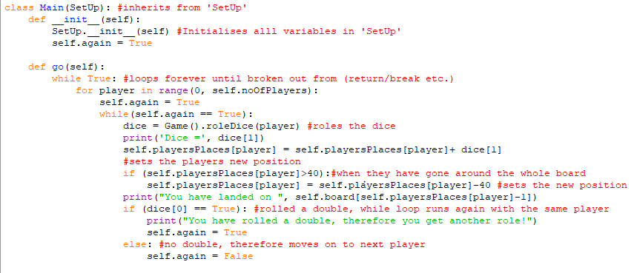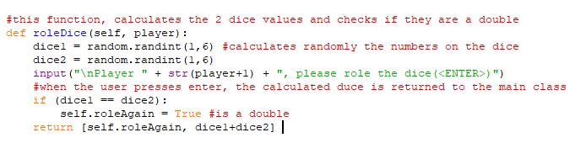

##### Objective 4: Passing go

When the player passes go, they must collect 200cc

To complete this objective, I decided to change objective 3 to have the if loop; where it checks if the player has completed a full cycle of the board, into a function named ‘pastGoCheck’. Which also checks once a player has completed a full cycle 200cc are added to their bank:

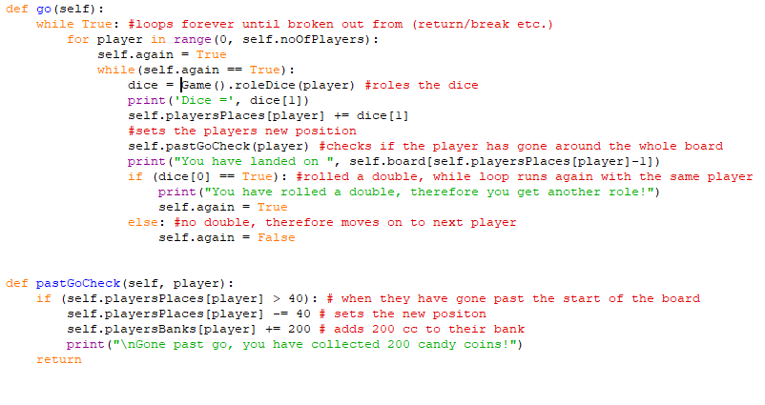At the start I was incrementing variables in a very long and inefficient way, for example :

self.playersPlaces[player] = self.playersPlaces[player]+dice[1]

However, with further research into python I found out that you can increment a variable by using ‘+=’ and decrement a variable by using ‘-=’. This made the code easier to read and less error prone for spelling mistakes.

##### Objective 5: Action that is taken, once landing on a square

When they land on a square the particular action must occur

1. If they land on a card, they are given a card from random and the action on the card takes place
2. If they land on free candy, they receive all the money under free candy
3. If they land on bills, they must pay the amount shown on the square
4. If they land on go to the dentist, they must be sent to the dentist
5. If the square is free to be bought, they are asked if they would like to

I first decided to create a function called ‘squares’ which takes the players positions and sends it to the correct function to carry out the squares action.

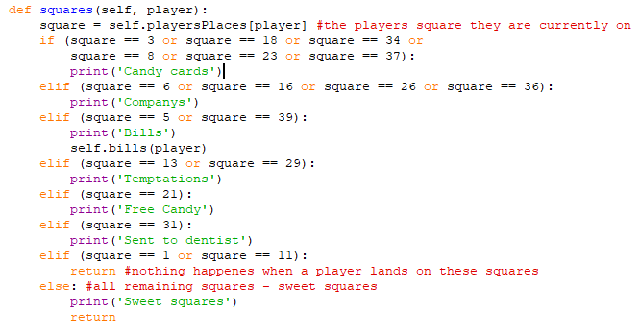

**Part 1:**

I decided to start with the action that happens after a player lands on cotton candy card by creating the function called ‘candyCards’ which takes the player, generates a random card and carries out the action given by the card. Whilst programming this section I realized that if a player lands on the cotton candy cards it could change the position of the player and whatever square they land on after this the desired action should take place, therefore the program now checks if they have landed on a cotton candy card first then it proceeds to the squares function.

(In the ‘SetUp’ class)

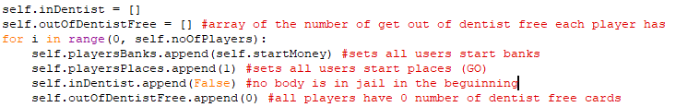

(In the ‘go’ function)

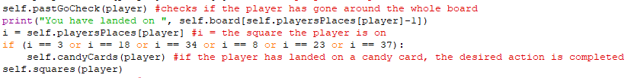

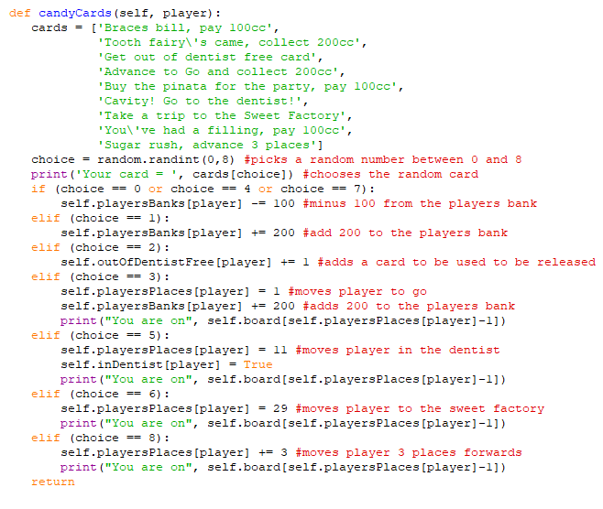

Example of some testing:

Testing if the player moves to the correct square when the cotton candy card says to.  
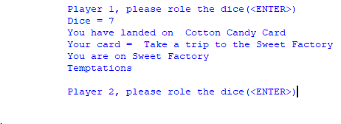

And

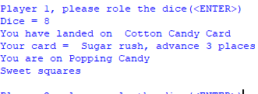

Testing to see if the bank updates if the player loses/gains money from the cotton candy card:

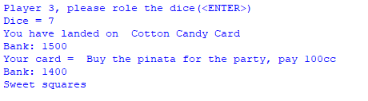

**Part 2:**

Free candy is collected, when players pay for bills, the money extracted from Cotton Candy Cards and the payment to exit jail, then when the square is landed on that player gets all the candy coins and the total goes back down to 0.

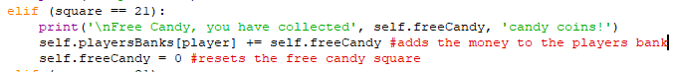Therefore to complete this part I need to add in the variable ‘freeCandy’, which is incremented, then when the player lands on the square the money goes in their bank and is set to 0.

**Part 3:**

If the player lands on ‘Sugar Tax’ or ‘Medical Bill’, they must pay 100cc and this money should go towards free candy. I have decided to make a function called ‘bills’, which minus 100 cc from the players banks and adds it to the total of ‘freeCandy’.

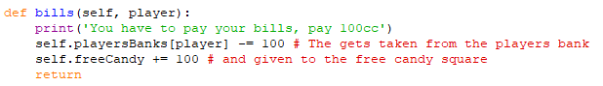

I have also decided to use this function, when the player gets 3 type of cotton candy cards which makes the user pay 100cc into ‘freeCandy’, to make the code more efficient as it is none repeated.



Example of some testing for part 2 and 3:

Shows the players pay their bills to the free candy, and once landed on the total number is given to the user.

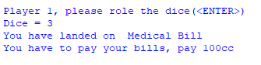

……………

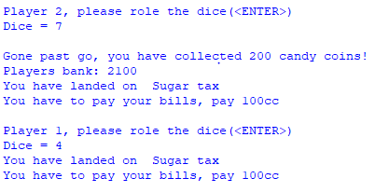

……………

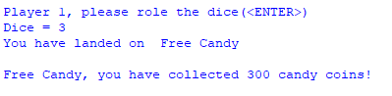

**Part 4:**

If they land in the ‘Go to the Dentist’ square, they must be sent to the dentist, therefore the players value in the array ‘inDentist’ must change and where the player currently is must change. Later on, when completing objective 8 I will sort out once they are in the dentist what happens.

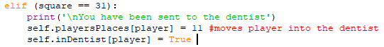

Example of testing:

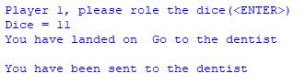

**Part 5:**

There are 3 types of properties you can buy:

1. Temptations
2. Companies
3. Candy Squares

For all 3 of the above, I am going to create a function called buy square, which takes the parameters 🡪 player and the price. If the square is not owned already, it will ask the users if they would like to buy it:

* If yes 🡪 the program must be able to save that this square now belongs to a player, and no other player can buy it throughout the program and must minus the price of the square from the players bank.
* If no 🡪 the program carries on to the next player.

I have decided to create an array called ‘owned’ initialized in the class SetUp, which relates to the boards positions, at the beginning each square is said to be ‘empty’, once a player buys a square, the related value changes from ‘empty’ to the players number -1.

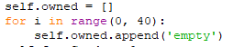

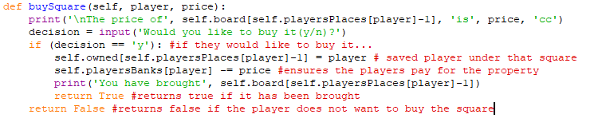

I am going to start with the ‘Temptations’, each temptation is 150cc to buy:

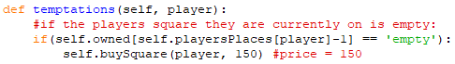

Example of testing:

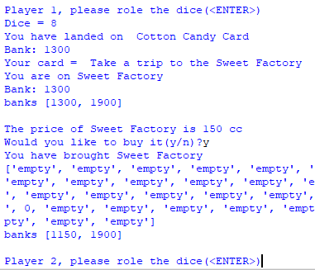

Allowed player 3 to buy the temptation and saved it correctly in self.owned and has also adjusted the players bank. When someone else later landed on ‘Sweet Factory’, there was not an option to buy it:

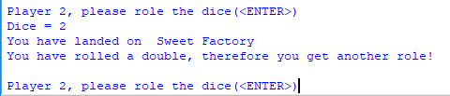

Next is when a player lands on a company, there are 4 companies: Maoams, Haribos, Chupa Chups and Drumsticks, all with the same price of 200cc.

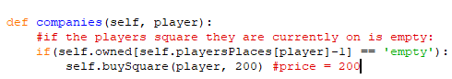

Example of testing:

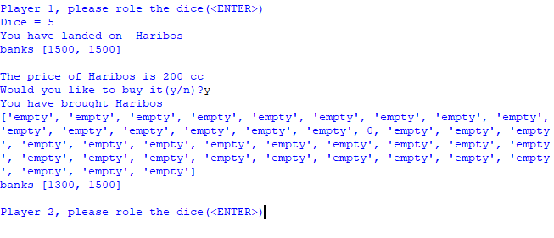

Has allowed the player to buy Haribos as it is empty and has also taken the price of the company off the players bank. Also when someone else later landed on ‘Haribos, there was not an option to buy it:

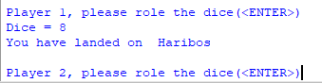

When a player buys a square

First I need to find a way that the information about the sweets can be represented, I am also going to include the information needed when adding bags. The information we need to find out about the candy is:

* Price to Buy
* The colour group it is on
* Its position – what square
* The price to add one bag/tub
* How many bags/tubs does it currently have on it
* How much would a player have to pay if landing on 0 bags , 1 bag etc.

To represent the information about the current square I originally thought it would be best to create a two dimensional array with the following information:

* The location (which square)
* How much to buy the square
* The current number of bags/tub on it
  + 0 = no bags
  + 1-4 = number of bags
  + 5 = 1 tub

e.g. Information for love hearts (if 2 bags were on it)

[2, 60, 2]

However, when trying to reference it later on in the program to find information such as the price, it was very hard and included a lot of referencing. Another way of representing this was to use a dictionary, where keys are used to map to certain values. Therefore if I wanted to look at the price for love hearts I would just search the dictionary for the key which in this case would be the location 2 and it would give all the information in an array.

E.g. sweets = {2: [60, 2], 4[60, 0], 7:[100,0]…….}

After I created the dictionary I thought I could also include more information in the dictionary:

* How much a bag/tub is to buy
  + A reference to a list:
    - bagPrices = [50, 100,150, 200]
    - colours:
      * Light pink and yellow = reference 🡪 0 – 50cc
      * Dark pink and light blue = reference 🡪 1 – 100cc
      * Green and purple = reference 🡪 2 – 150cc
      * Orange and dark blue = reference 🡪 3 – 200cc
* Price if a player lands on a square owned by another player:
  + I decided to have a 2 dimensional array – In the one array(named landedOnPrices) there would be 8 arrays (1 for each candy colour) with 6 values in each
    - 0,1,2,3,4 bags or 1 tub.
    - landedOnPrices = [[2, 10, 20, 90, 160, 250], [6, 30, 90, 270, 400, 550],[10, 50, 150, 450, 625, 750], [14, 70, 200, 550, 750, 950], [18, 90, 250, 700, 875, 1050], [22, 110, 330, 800, 975, 1150], [26, 130, 390, 900, 1100, 1275], [35, 175, 500, 1100, 1300, 1500]]
    - For example, if a player landed on strawberry laces (square 14) which is already owned with 3 bags, it would be referenced to the 3rd in the array 🡪 [10, 50, 150, 450, 625, 750]

Layout:

Sweets = {Location: [price, bagPrices ref, landedOnPrices ref, noOfBags], ….}

*(ref = reference)*

sweets = {2: [60, 0, 0, 0], 4: [60, 0, 0, 0], 7: [100, 0, 1, 0], 9: [100, 0, 1, 0],

10: [100, 0, 1, 0], 12: [140, 1, 2, 0], 14: [140, 1, 2, 0], 15: [140, 1, 2, 0],

17: [180, 1, 3, 0], 19: [180, 1, 3, 0], 20: [180, 1, 3, 0], 22: [220, 2, 4, 0],

24: [220, 2, 4, 0], 25: [220, 2, 4, 0], 27: [260, 2, 5, 0], 28: [260, 2, 5, 0],

30: [260, 2, 5, 0], 32: [300, 3, 6, 0], 33: [300, 3, 6, 0], 35: [300, 3, 6, 0],

38: [350, 3, 7, 0], 40: [350, 3, 7, 0]}

Therefore I initialized ‘sweets’, ‘landedOnPrices’ and ‘bagPrices’ into the class ‘SetUp’

The code below shows what happens when a player lands on a sweet square that is empty: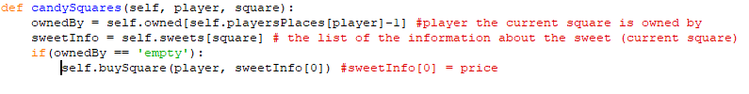

However, when I started to move onto objective 6, I thought it would be best to change what happens when you buy a candy square. I am going to add another two dimensional array (called sweetsOwned), this is used to show if the candy square is owned

* If it is empty = ‘’
* If a player owns the square it will contain that player’s number in that position of that square.

The ‘sweetsOwned’ array will contain 8 arrays inside, representing the colour group, inside these arrays will be the squares in that colour group:

sweetsOwned = [[LH,PV], [GB,GD,WG], [SL,SP,RB], [C,SB,FT], [CB,FCB,FBB], [GS,GC,GS], [FG,H,IM], [N,PC]]

The initials of the names of the squares has been put in however it will actually be represented like this:

sweetsOwned = [[‘’,’’],[‘’,’’,’’] ],[‘’,’’,’’] ],[‘’,’’,’’] ],[‘’,’’,’’] ],[‘’,’’,’’] ],[‘’,’’,’’] ],[‘’,’’]]

e.g. If player 1 owns SL, SB and FG:

sweetsOwned = [[‘’,’’],[‘’,’’,’’] ],[1,’’,’’] ],[‘’,1,’’] ],[‘’,’’,’’] ],[‘’,’’,’’] ],[1,’’,’’] ],[‘’,’’]]

Therefore, every time a player buys a candy square, their number should be added to sweetsOwned. To find the position of the square in sweets owned I need to be able to find the first position in the list and then the second. I decided to add another value to the end of each array in the sweets dictionary, which is the squares position in the inner array of sweetsOwned e.g. love hearts = 0, parma violets = 1. Then use the 3rd value in the lists as the first reference.

e.g. 24 = fizzy cola bottles

sweets[24][2] = 4 🡪 first position

sweetsOwned[4] = [[LH,PV], [GB,GD,WG], [SL,SP,RB], [C,SB,FT], [CB,FCB,FBB], [GS,GC,GS], [FG,H,IM], [N,PC]]

sweets[24][4] = 1 🡪 second position

sweetsOwned[4][1] = [CB,FCB,FBB]

New sweets dictionary:

Sweets = {2: [60, 0, 0, 0, 0], 4: [60, 0, 0, 0, 1],

7: [100, 0, 1, 0, 0], 9: [100, 0, 1, 0, 1], 10: [100, 0, 1, 0, 2],

12: [140, 1, 2, 0, 0], 14: [140, 1, 2, 0, 1], 15: [140, 1, 2, 0, 2],

17: [180, 1, 3, 0, 0], 19: [180, 1, 3, 0, 1], 20: [180, 1, 3, 0, 2],

22: [220, 2, 4, 0, 0], 24: [220, 2, 4, 0, 1], 25: [220, 2, 4, 0, 2],

27: [260, 2, 5, 0, 0], 28: [260, 2, 5, 0, 1], 30: [260, 2, 5, 0, 2],

32: [300, 3, 6, 0, 0], 33: [300, 3, 6, 0, 1], 35: [300, 3, 6, 0, 2],

38: [350, 3, 7, 0, 0], 40: [350, 3, 7, 0, 1]}

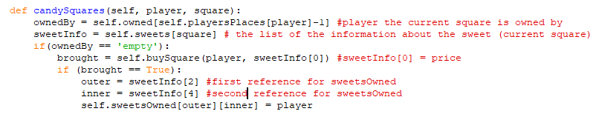Implementation:

##### Objective 6: Adding Bags/Tub to the players properties

When buying a bag these validations need to be put into place:

1. Each square with the same colour must have the equal number of bags belonging to it before another is added
2. Once there is a tub on each square of the colour, no more bags or tubs can be added

Firstly I created a new function called ‘addBagsTubs’, which is called from the function ‘go’. The first action the function does is check that a player can even add a bag or tub to a square, for this to happen, the following need to be true: they must have brought all the relating squares colours e.g. love hearts and parma violets or Chewits, starburst and fruit-tella.

Therefore the program needs to:

1. Check though each array in ‘sweetsOwned’,
   1. If all of values are equal to the players number in that array
      1. The outer number needs to be saved
      2. Squares names need to added to a list

I have also added another 2 dimensional array called ‘sweetNos’, which contains each candy square relating to the colour they are in.

self.sweetsNos = [[2,4], [7,9,10], [12,14,15], [17,19,20], [22,24,25], [27,28,30], [32,33,35], [38,40]]

Therefore if a player can add a bag/tub to a square if the length of canAddNames is not empty. The program then will output all viable options e.g. 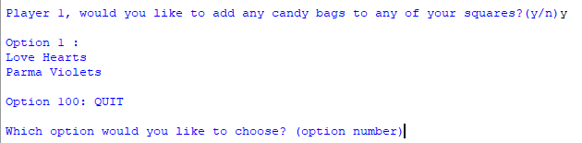

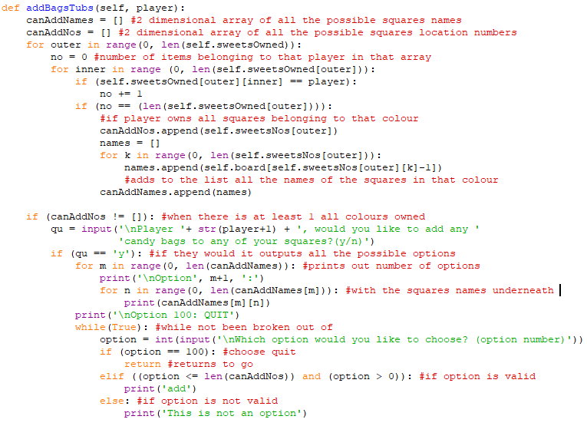

1. 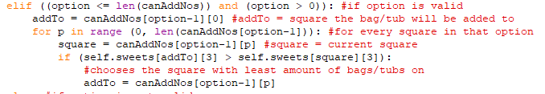Each square must have an equal number of bags before another is added
2. 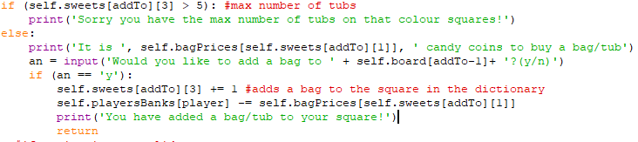Once there is a tub on each square of the colour, no more bags or tubs can be added

##### Objective 7: Paying rent

If a player lands on a square belonging to another player, that player must pay the other player the specific rent for that square

There are 3 types of properties you can buy:

1. Temptations
2. Companies
3. Candy Squares

**Part 1:**

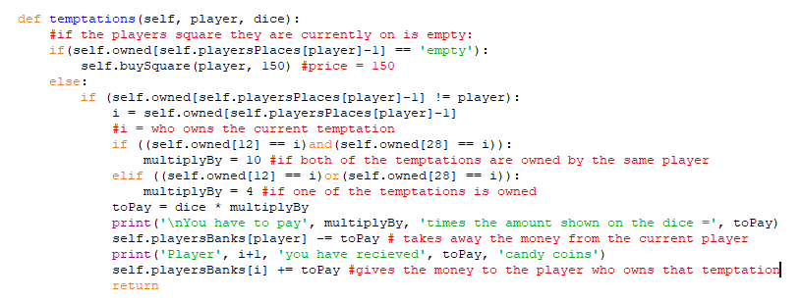When a player lands on a temptation, that is owned by another player, they must pay the other player. If the other player only owns that one temptation, they only have to play 4 multiplied by the number they have rolled on the dice. However, if they own that current temptation and the other one, the player must pay them 10 multiplied by the number shown on the dice.

**Part 2:**

When a player lands on a company, if the company has been brought the current player will need to pay the player who owns that company, if that player has..

* 1 company, the current player pays 25
* 2 companies …. pays 50
* 3 companies …. pays 100
* 4 companies .… pays 200

My idea was to go round a for loop looking into if the square for each company is owned by the player who owns the company the player is currently on, I have used the variable ‘howManyOwned’ to keep track of how many companies that one player owns.

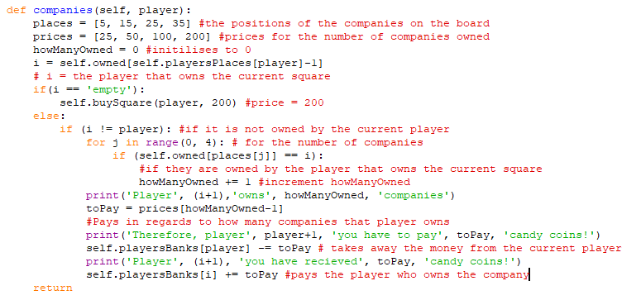

**Part 3:**

When a player lands on a candy square, if the square has been brought the current player will need to pay the player who owns that square, the amount to pay depends on

* How much the rent is with the number of bags on that square

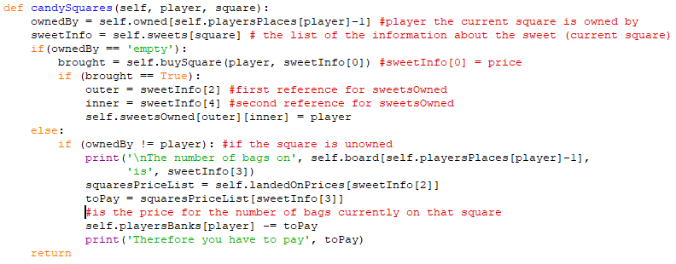Therefore in this function ‘candySquares’, if the property is owned, the number of bags on the square needs to be located from the ‘sweets’ dictionary, and the price is then calculated from ‘landedOnPrices’.

##### Objective 8: Released from the dentist

At the beginning of each go I need to check if the current player is in the dentist, if they are the program should take them to a function that gives them options to try and be released:

1. Pay 50 *cc*
2. Roll a double
3. Use a get out of *dentist* free card (if owned)

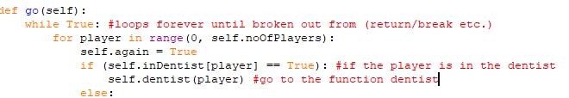

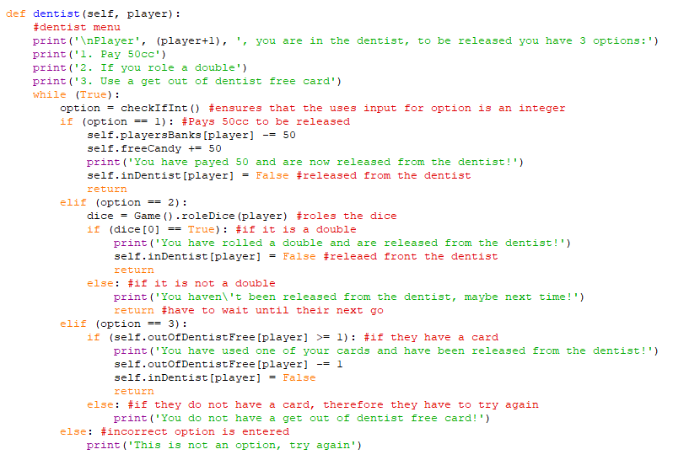Therefore if a player is in jail it goes to this function:

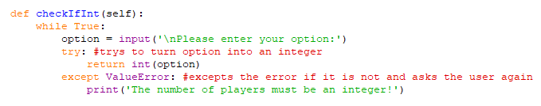Further validation for ‘option’:

I also need to update the program, so if a double is rolled on the players first go and they get sent to jail, they do not get another go and the program should move onto the next player. Therefore, I have added this onto the end of the function ‘go’.

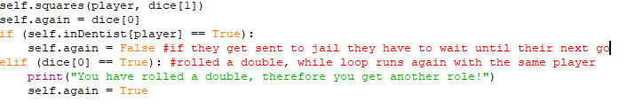

##### Objective 9: Winning/losing the game

First, after each player’s turn I am going to check if their banks are less than 0, if they are that makes them bankrupt. Therefore, I have added in the statement below near the end of the ‘go’ function, I have added it here in case they roll a double and go bankrupt before their second roll. I have created a variable called ‘self.lost’ which keeps track of how many players are out of the game.

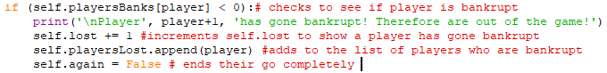

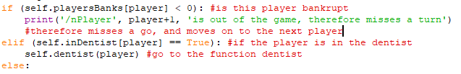Second, at the beginning of every turn, the program needs to check if the current player is still in the game (not bankrupt), if they are they miss their go, if not the game carries on.

Lastly before every go the program needs to check if there is only one player left, therefore that player has won. This would be true if ‘self.lost’ is equal to the number of players minus 1.

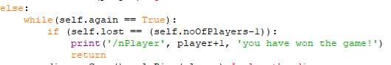

## Testing

In this testing I’m going to play a whole game doing normal, boundary and erroneous tests. I will be using my paper board (See Annex 1) to visually see what is going on.

### Test Plan

#### Table 7: Test Plan

|  |  |  |  |  |
| --- | --- | --- | --- | --- |
| No | Input Data | Expected output | Objective | Comment |
| 1.1 | 2 | Each player starts with 1500 candy coins! | 2 | Testing simple input for how many players and to see if players start with 1500 cc |
| 1.2 | 10 | There can only be 2 to 6 players  How many players are there? | 2 | Testing if the validation for an integer out of the scope works |
| 1.3 | One  3 | The number of players must be an integer!  How many players are there? |  | Testing if validation works for entering a different data type then an integer and to see if they program carries on |
| 2 | <ENTER> | Dice = …..  You have landed on…..  *Action to be carried out* | 3 | Tests that the player moves around the correct no of times and lands on the correct square |
| 3 | <ENTER> | You have rolled a double, therefore you get another roll!  Player …, please roll the dice(<ENTER>) | 3 | If a player rolls a double, the program should allow them to have another turn |
| 4 | <ENTER> *until player passes go* | Gone past go, you have collected 200 candy coins!  *Their bank must have +200* | 4 | To see if when a player passes go their banks get 200cc added |
| 5.1 | <ENTER> | You have landed on: Cotton Candy Card  Your card: …………..  *Completes action* | 5a | Tests if the card givens action is completed |
| 5.2 | <ENTER> | You have landed on: Cotton Candy Card  Your card: …………..  *Completes action* | 5a | Tests that it is random cards are given and tests another cards action |
| 6 | <ENTER> | You have landed on: Free Candy  You have collected …. Candy coins!  *Their bank must add the collected money* | 5b | Tests when landing on free candy, the player collects the money on the square |
| 7 | <ENTER> | You have landed on: bills  You have to pay your bills, pay 100cc | 5c | Testing when landing on a bill, if the correct amount of money is taken away |
| 8 | <ENTER> | You have landed on: go to the dentist  You have been sent to the dentist | 5d | To test if when a user lands on ‘Go to the dentist’ that they are sent to the dentist |
| 9.1 | <ENTER>  y | You have landed on …  The price of …… is .. cc  Would you like to buy it(y/n)?y  You have brought ….  (*updates banks)* | 5e | To test if a temptation is landed on, it allows the user to buy it if they input ‘y’, if it is empty |
| 9.2 | <ENTER>  N | *(nothing)* | 5e | To test when a square is landed on, and they user does not want to buy it |
| 10 | <ENTER>  Y | You have landed on …..  The price of ….. is 200 cc  Would you like to buy it(y/n)?y  You have brought …..  *(updates bank)* | 5e | To test if company is landed on, it allows the user to buy it if they input ‘y’ if it is empty |
| 11 | <ENTER>  y | The price of …..is … cc  Would you like to buy it(y/n)?y  You have brought ..  *(updates bank)* | 5e | To test if a non-owned candy square is landed on, it allows the user to buy it if they input ‘y’ |
| 12.1 | 1 | You have payed 50 and are now released from the dentist!  *Bank updated*  *Out of dentist on next go* | 8 | To see when the user chooses the option to pay 50 to be released from the dentist |
| 12.2 | 2  *(when they roll a double)* | You have rolled a double and are released from the dentist! | 8 | To see if when a user rolls a double, they can be released from the dentist |
| 12.3 | 2  *(when they do not roll a double)* | You haven't been released from the dentist, maybe next time! | 8 | To see what happens when a user does not roll a double to be released from jail |
| 12.4 | 3  *(when player has a card)* | You have used one of your cards and have been released from the dentist! | 8 | To see if when a user has a get out of the dentist free card and it is used, they can be released from the dentist |
| 12.5 | 3  *(when player doesn’t have a card)* | You do not have a get out of dentist free card!  Please enter you option: | 8 | To see if when a user does not have a get out of the dentist free card and tries to use one there should be a error message |
| 13.1 | <ENTER> | You have landed on,….  The number of bags on …. is 0  Therefore you have to pay … | 7 | To test if when a player lands on a candy square that is owned that it pays the correct amount of money when there is no bags on it |
| 13.2 | <ENTER> | The number of bags on …. is (1-4)  Therefore you have to pay 50 | 7 | To test if when a player lands on a candy square that is owned that it pays the correct amount of money when there is bags on it |
| 14 | <ENTER> | Player 2.. please roll the dice(<ENTER>)  Dice = 5  You have landed Sweet Factory  Bank: 890  You have to pay 4 times the amount shown on the dice = 20  Player …. you have received 20 candy coins | 7 | When a player lands on a players square which owns one or both temptations, they must pay the correct amount of money to the other player (4 or 10 times the number on the dice) |
| 15 | <ENTER> | You have landed on …..  Player .. owns .. companies  Therefore, player .. you have to pay … candy coins!  Player 1 you have received .. candy coins! | 7 | When a player lands on a players square which owns more than one company, they must pay the correct amount of money to the other player |
| 16 | <ENTER> | You have landed on…  Player .., please roll the dice(<ENTER>) | 7 | To test what will happen when a player lands on a square that they own |
| 17.1 | *(when a player owns all squares of a colour)*  *Y*  *1* | Player 1, would you like to add any candy bags to any of your squares?(y/n) y  Option 1 :  *Square 1*  *Square 2*  *Square 3*  Option 2:  *Square 1*  *Square 2*  *Square 3*  Option 100: QUIT  Which option would you like to choose? (option number)1  Would you like to add a bag to ……?(y/n)y  You have added a bag/tub to your square! | 6a | Test to see if a bag can be added to a square in the colour category of the chosen option and the banks are updated and to check that only bag can be added at one time |
| 17.2 | Y  1  Y  1 | Player 1, would you like to add any candy bags to any of your squares?(y/n) y  Option 1 :  *Square 1*  *Square 2*  *Square 3*  Which option would you like to choose? (option number)1  Would you like to add a bag to *square 1*?(y/n)y  You have added a bag/tub to your square!  Player 1, would you like to add any candy bags to any of your squares?(y/n) y  Option 1 :  *Square 1*  *Square 2*  *Square 3*  Which option would you like to choose? (option number)1  Would you like to add a bag to *square 2*?(y/n)y  You have added a bag/tub to your square! | 6b | Test to see if each square of that colour has the equal number of bags on it before another is added |
| 17.3 | Y  1 | Sorry you have the max number of tubs on that colour squares! | 6d | Test to see that once there is a tub on every square of that colour, no more can be added |
| 18 | *none* | Player 2 has gone bankrupt! Therefore are out of the game! | 9 | To test to see if when a player goes bankcrupt they are out of the game and miss their goes |
| 19 | *none* | Player 1 you have won the game! | 9 | To test when all but one player has gone bankrupt, that there is a winner and the game ends |

### Test Log

#### Table 8: Test Log

|  |  |  |
| --- | --- | --- |
| No | Actual Output | Correct? |
| 1.1  1.2  1.3 |  | Yes |
| 2 |  | Yes |
| 3 |  | Yes |
| 4 |  | Yes |
| 5.1 |  | Yes |
| 5.2 |  | Yes |
| 6 |  | Yes |
| 7 |  | Yes |
| 8 |  | Yes |
| 9.1 |  | Yes |
| 9.2 |  | Yes |
| 10 |  | Yes |
| 11 |  | Yes |
| 12.1 |  | Yes |
| 12.2 |  | Yes |
| 12.3 |  | Yes |
| 12.4 |  | Yes |
| 12.5 |  | Yes |
| 13.1 |  | Yes |
| 13.2 |  | Yes |
| 14 |  | Yes |
| 15 |  | Yes |
| 16 |  | Yes |
| 17.1 |  | Yes |
| 17.2 |  | Yes |
| 17.3 | I was unable to get this test as the program never got as far as going past having tubs on every square of that colour | Incorrect |
| 18 |  | Yes |
| 19 |  | Yes |

# Evaluation

In my evaluation I will refer to my objectives for the simple program and will assess the extent to which I met each objective and identify ways in which the program could be improved. In my simple program I have programmed in python in an object orientated way throughout.

**Objective 1: An original board needs to be created and be able to be represented in python**

This objective was met in full; I created an original board on the lines of the candy theme, I was able to represent my board using an array, where it was possible to identify each square with its number and link it to the name saved in the boards array.

**Objective 2: The program can only have 2-6 players that start off with 1500 candy coins**

This objective was met in full; as shown in testing, when the user was asked how many players they would like, the only value that was accepted was an integer between 2 and 6, another option was validated and error messages dealt with this problem. At the start of the program, all players banks were set to the start money which is 1500 candy coins.

**Objective 3: Each player has a counter that must be able to move around the board by the total number of 2 dice**

* 1. **If they get a double, after their first go, they get to roll again**

This objective was met in full; at the beginning of every go the user would have to roll 2 dice and with the total of the dice the player was to move around the board. I used an array called playersPlaces which kept track of where each player was by adding the dice total every turn. If the 2 dice that were rolled equaled, the player was allowed to get another go.

**Objective 4: When the player passes go, they must collect 200 cc**

This object was met in full; every time the program ran it checked if the current players position plus the total of the dice was bigger than the size of the board(40), if it was, 40 would be taken away from the current players position and 200 cc would be added to the players bank.

**Objective 5: When they land on a square the particular action must occur**

1. **If they land on a cotton candy card, they are given a card from random and the action on the card takes place**

5a was met in full; as when a player lands on a cotton candy card a card is chosen at random and the action on that card was always completed correctly e.g. banks were updated, players were moved etc.

1. **If they land on free candy, they receive all the money under free parking**

5b was met in full; as whenever a player landed on the free candy, the money that was on it was taken off the square and added to the players bank and the value of free candy was set back to 0.

1. **If they land on bills, they must pay the amount shown on the square**

5c was met in full; as whenever a player landed on a bill 100cc was taken off from the players bank and added to the free candy.

1. **If they land on go to the dentist, they must be sent to the dentist**

5d was met in full; as when the player would land on this square they were sent to the dentist and in their next go they had to pick from the 3 options to be released.

1. **If the square is free to be bought, they are asked if they would like to buy it**

5e was met in full; for companies, temptations and the candy squares, if the current square was free, the user was asked if they would like to buy the square, if they entered ‘y’ the amount for the square would be taken off their bank and they would now own that square, if they did not the program would carry on.

**Objective 6:Once one player has all the candy squares of a particular colour, they must be asked if they would like to add any bugs or tubs to the square**

1. **Can only add one bag/tub at time**
2. **Each square with that colour must have the equal number of bags belonging to it before another is added**
3. **Once they have 4 bags on each square, a tub can be added**
4. **Once there is one tub on each square of the colour, there can be no more added**

Objective 6 was mostly met; the user would only be asked to add any bags or tubs if they owned all of the squares of a particular colour, if they didn’t the program would carry on, if they did, the user would be asked if they would like to add any bags to the square. The loop only went round once therefore only one bag/tub could be added at a time. The square that the bag is added to is decided by comparing how many bags there are and the square with the least is the square that the bag gets added to.

To complete 6c and 6d, I had to change some values of variables to in the program then test it as it was very difficult for a player to add tubs to each square before going bankrupt, therefore I have not tested it without changing the variables in the program, therefore I cannot be 100% sure that it is correct without the variables being inputed.

**Objective 7: If a player lands on a square belonging to another player, that player must pay the other player the specific rent for that square**

This objective was met in full; whenever a player landed on a square that was owned by another player, the price was calculated correctly and taken away from the players bank and added onto the owners bank. This worked for all squares; temptations, companies and candy squares.

**Objective 8: If a player has been sent to the dentist, the next go they get 3 options to try and be released**

1. **Pay 50 cc**
2. **Rolled a double**
3. **Use a get out of the dentist free card (if owned)**
4. **After they have chosen a correct option, the game moves on to the next player**

Objective 8 was fully met as shown in testing; when option a. was chosen, 50cc was taken away from the players bank and added to free candy. If option b was chosen, they had to roll the dice, if it was a double they were released from jail, if not they had to stay in there for another turn. Option c could only be chosen if the player had a dentist free card, which would release them for the dentist, if they did not have the card then validation was in place to avoid an error.

**Objective 9: Every time the program is run, it must check if a player has gone bankrupt (therefore misses a go), and if there is a winner (the rest of the players are bankrupt)**

The final objective, was fully met; as at the end of every go, the program checks if the user is bankrupt and a variable called lost is incremented if they are. At the beginning of every turn the program checks to see if there is a winner by seeing if all players apart from one is bankrupt, if this is true that player has won the game. This is also displayed to the user as you can see in my testing.

Throughout my simple program I came across a lot of errors however, with further research into python I solved them in due course and I was able to complete most of the objectives set out with the exception of Objective 6c and 6d where, the program has not run that far yet. However the success of the other objectives allows me to move onto my development of the GUI. I recognize I could have some improvements in my simple program, however my aim was to ensure this was functional so I could use it for my GUI. To improve the program, I would have used less variables and had better variable names .

# The Graphic User Interface

## Introduction

In this program I am going to create the game of Monopoly, with a GUI, sticking to programming in an object orientated way. I am going to design my board, counters etc. and use them to allow the user to play Monopoly on the interface, ensuring all rules and criteria are followed. I will be programming in python still, however will be using one of its libraries called Pygame, as I have never used this before I will need to research into this and use tutorials to help me implement the program. My GUI is made so that playing my game is more enjoyable and easier to follow rather than using the simple program and the paper board, see Annex 1: Draft Paper Board Design

## Plan

I am going to plan the set out of the program and design the board that can be used in the GUI effectively. My GUI must still follow the rules and criteria of my Candy Monopoly. Throughout implementation I must follow the objectives efficiently to create a working graphic user interface. After implementing the game I will do effective testing to ensure it works to the best of its ability and then end with an evaluation. After I have finished the GUI, I will go on to create the computer player.

### Objectives

1. Do some research into Pygame, to develop my understanding so I can apply it
2. Design and create an original board, as well as collect images for counters, bags, tubs.
3. Download the Pygame module, so it can be used in the program
4. Create the GUI screen, which contains the created board
5. Update players, so the user clicks on a button to decide the number of players (only 2-6 players allowed), it should be displayed to the user that all players start with 1500cc
6. The users must be able to click on a button to roll the dice, where the total dice must be calculated and displayed to the user
   1. If they get a double the player gets to roll again
7. To find a way to store the squares positions on the board
8. Allow the counters to be used in the GUI where they must be allowed to move around on the board by the total of the dice
   1. If they pass go 🡪 collect 200cc
   2. The square they’ve landed on must be displayed
9. Before every go the player must be asked if they would like to see a list of their properties or continue
   1. List of their properties = any square that they own
10. When a player lands on an unowned square the said action must take place
    1. If the action requires an answer, the user is asked and there are appropriate buttons to allow the user to make the decisions.
11. When a player lands on an owned square the player must pay the appropriate amount to the player who owns that square
12. If the current player has all the candy squares of the same colour, they must be given the option (yes/no button) to add any bags or tubs to a square
    1. Same rules apply for adding bags – one at a time etc.
13. When a player is in the dentist, they are still given 3 options (buttons)
    1. Cannot click on ‘Use a get out of dentist free card’ if it is not owned
14. Every time the program is run, it must check if a player has gone bankrupt (therefore misses a go), and if there is a winner (the rest of the players are bankrupt)

### Pygame Research

My first objective is to research into Pygame, finding out what it is and what it’s used for and the benefits and drawbacks of the library.

Pygame is a library in python that is used to for making multimedia applications, which includes modules for graphics, music, sound, video etc.

Benefits:

* Highly portable
* Runs on lots of platforms and operating systems
* It’s said to be simple and easy to use
* Multi core CPUs can be used easily
* The code can be kept simple

Drawbacks:

* It is not very powerful for more complicated projects

I think Pygame is a good library to use for my GUI, as I am very new to creating GUI it will hopefully be easy for me to use. Throughout the process of creating this program, I will be researching into how to implement certain bits of my program into a GUI e.g. how to create buttons.

## My Approach

* Whenever an option needs to be made with a yes or no answer there will be yes or no buttons to answer the question.
* When the program asks for the number of users, have buttons 2-6 for the user to choose
* Whenever an action takes place, there needs to be a button to continue onto the next bit of the game.
* To roll the dice the user should press a button
* The counters will be moved around the screen by updating the board every roll
* Players should be able to view their properties before every turn
* When a player adds a bag/tub to a square this should be displayed somehow on the screen

## Design

To complete my second objective, I am going to design and create a board that can be used in the GUI, it is going to be original and interesting. I will also be finding or creating the counters, bags and tubs that will also be used, as well as designing how the screen will look and how the user will interact with it.

### Designing My Board

My draft paper board: Annex 1: Draft Paper Board Design, is going to be a big part in creating my board as I already have the basic layout of the board. I am going to be using images from Google images to use as backgrounds for squares etc. I am making this board entirely from scratch and will be using Pixteller.com, a website used for creating designs for posters and more.

##### Design for candy squares

For each candy square, I have decided to only have a picture of the sweet and the colour block instead of writing on the square what it is. e.g. for cola bottles:

This is because my program is going to be used on laptops, therefore the board won’t be as big, I also think that if I had writing on every square, the board would be more hectic and confusing, especially for younger players. The name of the square will also always be displayed on the side panel/new window, e.g. You have landed on cola bottles.

##### Design for Tax’s and Go

For the tax squares I am going to have quite a simple design, with very bold writing on it, so it is clear to the user.

##### Design for temptations

I am going to have the writing and the price on this square with this background:

##### Design for companies

I am having the companies names on quite a clear background:

So it is clear to the user and it stands out.

##### Design for candy cards

I am going to have cotton candy background with ‘Cotton Candy Cards’ written on the top very clearly.

##### Design for free candy

I am going to have a basic background with writing over the top.

##### Design for dentist squares

On ‘Go to the dentist’ and ‘Just visiting’ squares, I am going to use dentist images along with the text on the top.

##### Whole Board Design

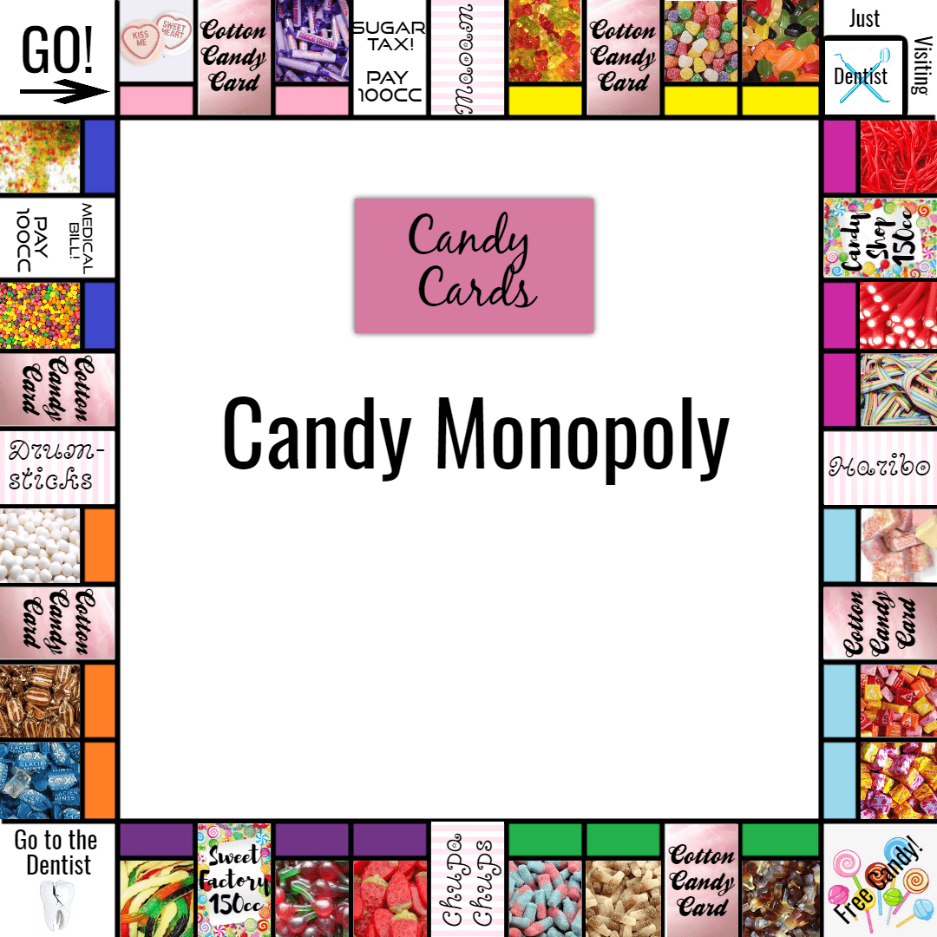Using pixteller.com I was able to create the board below:

Illustration 4: Whole Board Design

##### Design for players counters

I found this cartoon candy, and I thought I could use it as my players counters and change the colour for each player. This was the original image:



I then used a program called ‘GIMP’ to change the colour of the counters as well as make their background translucent by changing the colour 🡪 alpha. There can be up to 6 players, therefore I created 6 new counters:



##### Design for bags and tubs

I am going to use this bag and this tub to show that a player has added to their candy squares, there can be up to 4 bags but only one tub. I also used ‘GIMP’ here to make their backgrounds translucent.

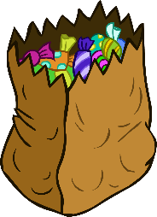Bag:

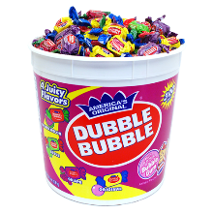Tub

I made their backgrounds translucent so it’s just the image on the screen, not a white block behind the images.

I have decided I am not going to have the bag/ tub shown on the actual board, as the screen that my intended users are going to be playing this on will be small therefore it will be hard to see the bags and be clear if I put them on the board, therefore, I will show the number of bags/tubs whenever a player lands on a square with a bag/tube and when adding bags/tubs to the players squares.

### Screen Design

Here is the screen design I have made for my GUI:

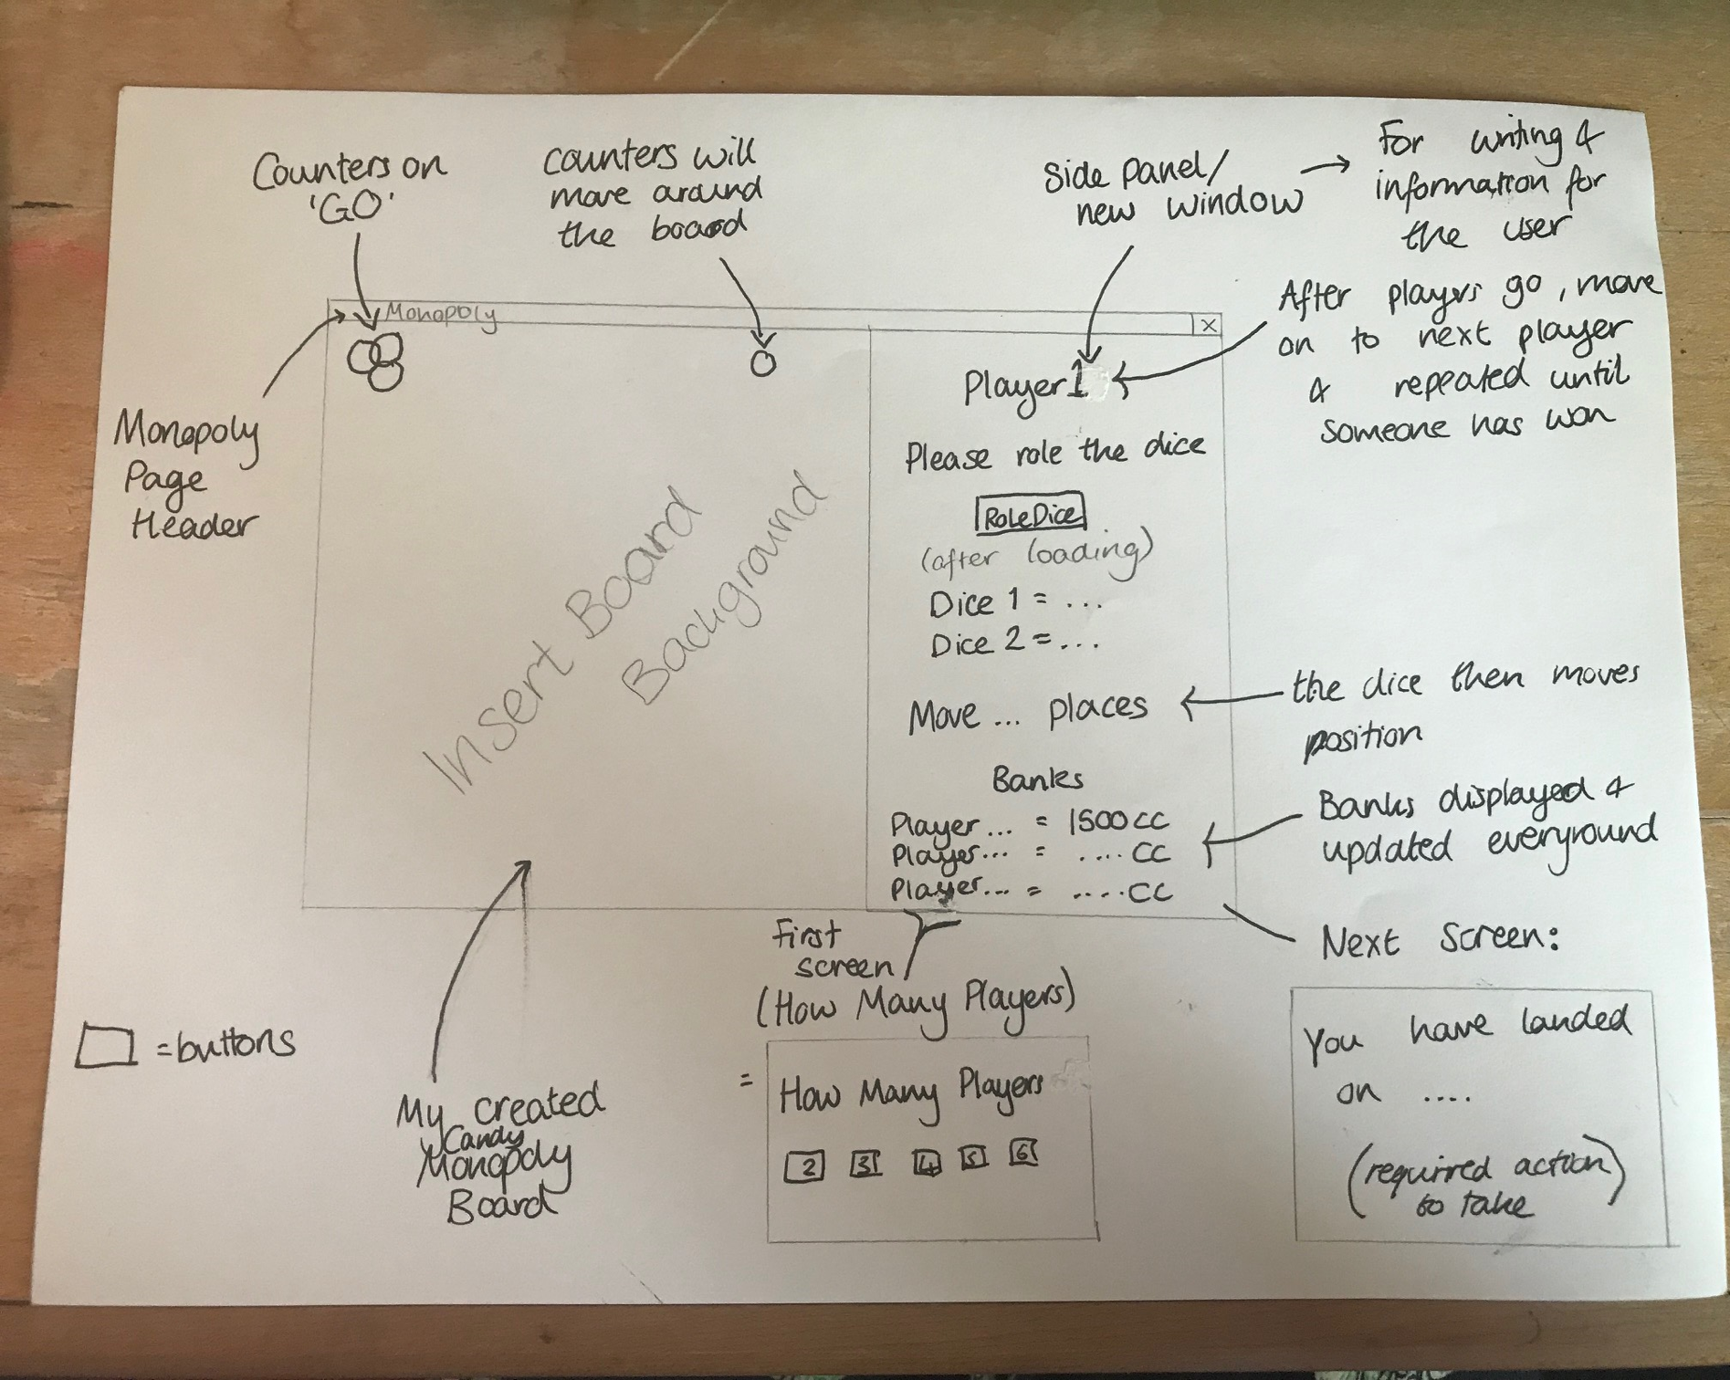Illustration 5: Drawn Screen Design

## Implementation

##### Functions in the GUI program (including functions built in to Pygame)

I will be adding to the functions that were created in the simple program, from the GUI program, and will be adding to it as I go along. I will not include functions already defined in the simple program.

#### Table 9: Functions in the GUI program

|  |  |  |
| --- | --- | --- |
| Name | Which class | Why is it used/what is returned(if anything) |
| set_mode | Pygame library | Initializes a window or screen for display |
| set_caption | Pygame library | Sets the current windows caption |
| Pygame.font.Font | Pygame library | Creates a new font object |
| Pygame.image.load | Pygame library | Loads an image from a file |
| Pygame.display.update | Pygame library | Updates the screen since the last update |
| createScreen | GUIfunctions | Creates the screen, with the title, board and input/output screen |
| Pygame.mouse.get_pos | Pygame library | Gets the mouse cursor position |
| Pygame.mouse.get_pressed | Pygame library | Gets the state of the mouse buttons |
| click | GUIfunctions | Gets the location and size of a button, if the button is clicked it returns true |
| .blit | Pygame library | Draws one image onto another |
| textF | GUIfunctions | Sets the text to the desired font and colour |
| sideText | GUIfunctions | Displays the message in the side part of the screen |
| Pygame.event.get | Pygame library | Gets events from the queue |
| Pygame.quit | Pygame library | Un-initializes all the Pygame modules |
| Sys.exit | sys library | Exits from python |
| toQuit | GUIfunctions | Allows player to quit |
| updateBoard | GUIfunctions | Clears the board and for every counter, there positions are updated |
| clearSideScreen | GUIfunctions | Clears the input/output part of the board |
| Pygame.transform.scale | Pygame library | Resizes to a new resolution |
| Create counters | SetUp | Loads the images for the number of counters needed |
| diceGUI | Game | Outputs to the user what is seen on the dice |
| rollDice | Game | Waits for the user to click the dice to roll the dice – which then goes to the function calculate duce |
| calculateDice | Game | Calculates the two dice values and if it is a double |
| noPlayerGUI | Main | Ouputs the number of players left and the player whose turn it is currently as well as a picture of their counter so the players can see what counter they are |
| banks | Main | Outputs all the players banks at the bottom of the side screen |
| landedOn | Main | Ouputs the square the player has landed on |
| continueB | Main | The continue button, when pressed it continues onto the next function |
| listProperties | Main | Lists all the properties belonging to that player |
| Pygame.draw.rect | Pygame library | Draws a rectangle |

##### Objective 3: Downloading the Pygame Library

In python 3.6, as it is a late version, pip is already installed on my computer. Pip is used to download the library Pygame. I went through lots of different websites trying to find out how to download the Pygame Library, however none of them worked until I came across [How To Install Pygame 1.9.3 for python 3.6](https://stackoverflow.com/questions/48213358/how-to-install-pygame-1-9-3-for-python-3-6) (Stack Overflow, 2018).

These are the final steps I had to take to install Pygame:

1. Download ‘pygame-1.9.3-cp37-cp37m-win32.whl’ from Christoph Gohlke(2018).
2. I then had to find the ‘Scripts’ folder in the file explorer
3. And paste the downloaded whl in the folder
4. I proceeded on to open the PowerShell window
   1. In this shell I had to enter (case sensitive):
      1. py -3.6 -m pip install Pygame
5. Pygame was then shown to be installed:

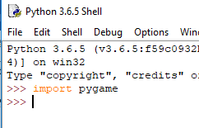

I then tested if the library had correctly installed buy entering ‘import pygame’ into the shell and there was no error message, therefore it had correctly installed.

##### Objective 4: Creating the Window and Importing the Board

Whilst completing this objective I have looked more into implementing Pygame. I used the Introduction to Pygame tutorials though out the creation of the GUI available at <https://pythonprogramming.net/pygame-python-3-part-1-intro/> .

These tutorials helped me find where to start programming the GUI. Therefore using this website, I decided to create a screen with width 900 and height 600, the program then uses the built in function set_mode, to create the window.

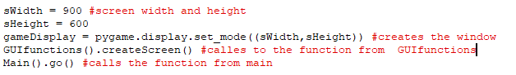

Firstly I thought it would be best to create a class with functions just relating to the GUI part of the program, this class will be inherited and initialized in the classes SetUp and Game. I then created a function called ‘createScreen’) which:

* Uses set_caption tp title the window ‘Candy Monopoly’
* Loads the image of the board
  + 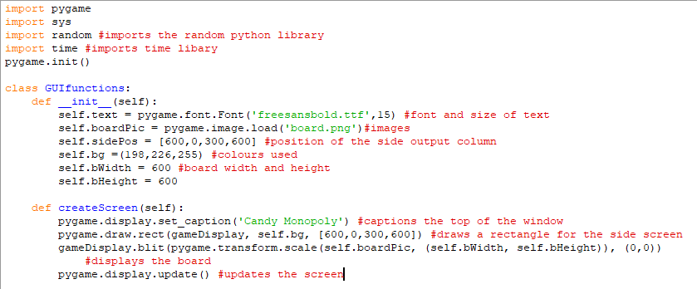Scaled to be the correct width and height and placed in the corner of the screen

This function produced the screen:

Illustration 6: Screen

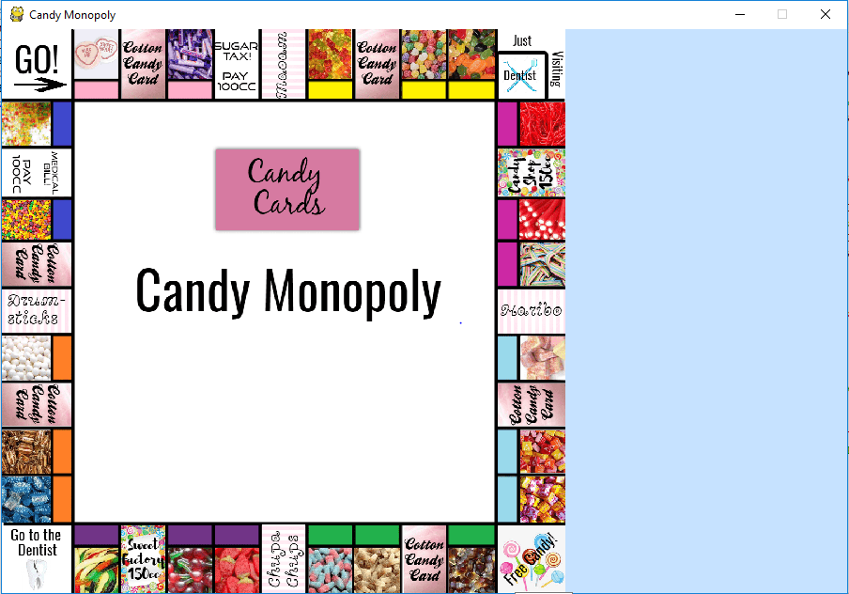

##### Objective 5: Update Players and Display Banks

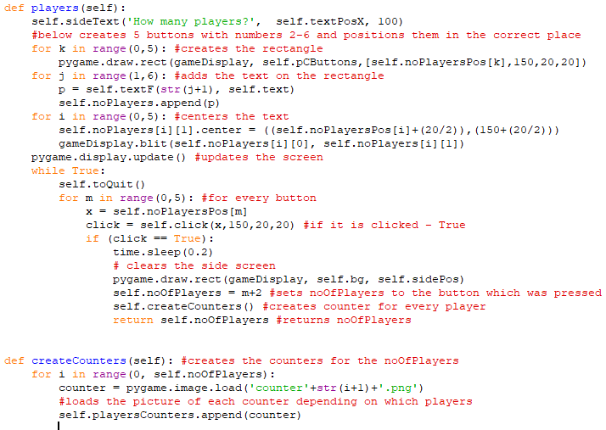I am using the side of the board to be the output/input screen. The first input that the program needs from the user is the number of players, (between 2-6). I have decided to create 5 buttons for 2 player, 3 player, 4 player, 5 player, 6 player. The program then loads a counter for every player. Once a button is clicked it moves on to the next part of the program. The function ‘players’ uses various functions in the GUIfunctions class.

During the completion of this objective, I have created the 4 new functions in the GUIfunctions class:

1. textF 🡪 Sets the text to the desired font and colour
2. sideText 🡪 Displays the message in the side part of the screen
3. toQuit 🡪 gives the option for the player to quite the game
4. click 🡪 takes the location and size of the button, if the mouse is clicked whilst its position is over the button, click equals true therefore the button is pressed.

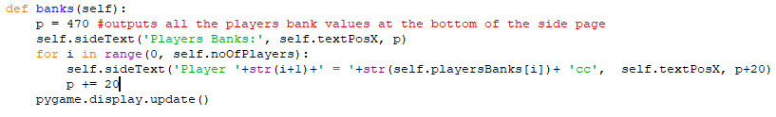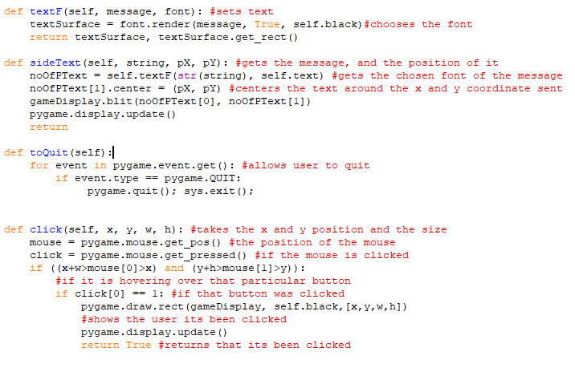When displaying that each user has 1500cc to begin with, I have decided to display the users banks at the beginning of every go before they roll the dice, at the start each player has 1500cc in their bank, and after every turn their banks are updated. This function is called in the function ‘go’.

### Objective 6: Rolling the dice

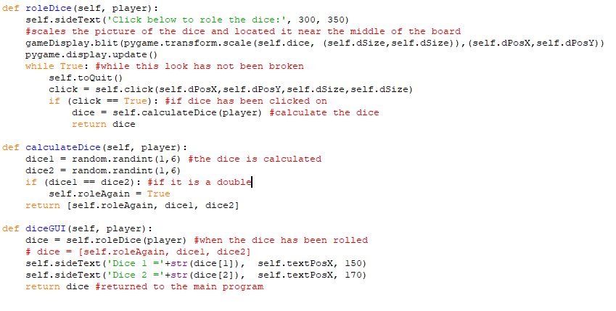When rolling the dice, I thought it would be good to have a button located on the board, when clicked the dice is calculated and displayed to the user.

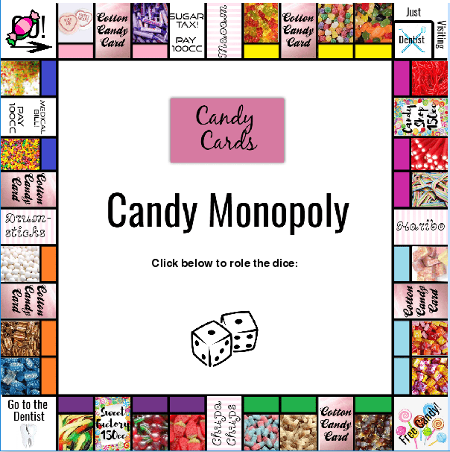

Illustration 7: Dice

After every go the variable, self.double equals true if the dice were a double, if not is a false. Before the dice is rolled in each game, if self.double is true it is displayed to the user that they have rolled a double, therefore they get another go.

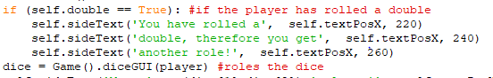

##### Objective 7: Representing the squares positions

I decided to find the middle position of every square around the board and save it into a two-dimensional array called boadPos, to do this I used the built in functions:

mouse = pygame.mouse.get_pos() #the position of the mouse

click = pygame.mouse.get_pressed() #if the mouse is clicked

I found the positions by outputting the position I clicked and saved the x and y values in the array. Although this is very time-consuming, I think it is an accurate way of finding the position for the counters as they make their way around the board. In the two dimensional array, each square will hold the x and y position:

self.boardPos = [[10, 10], [75, 10], [125, 10], [175,10], [225,10], [275,10], [325,10], [375,10], [425,10], [475, 10], [545, 10], [545, 80], [545, 125], [545, 175], [545, 225], [545, 275], [545, 325], [545, 375], [545, 425], [545, 475], [545, 545], [475, 545], [425,545], [375,545], [325,545], [275,545], [225,545], [175,545], [125, 545], [75, 545], [10, 545], [10, 475], [10, 425], [10, 375], [10, 325], [10, 275], [10, 225], [10, 177], [10, 125], [10, 80]]

e.g. The position of Chewits (square = 16)

self.boardPos[16-1] 🡪 x = 545, y = 275

##### Objective 8: Moving the Counters

At the moment, the players counters are all in one position, therefore we can only see one counter which is covering the rest, I think it is for the best to change this, so all players counters can be seen at once.

I have created a function in GUIfunctions that adds the extra position to the counter, this is updated every time the counter is moved to a new position.

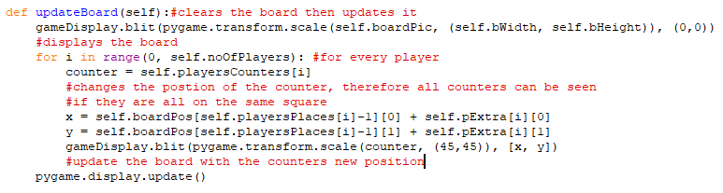

To make the counters move we just add the total of the dice to the playersPlaces. updateBoard will also update the position of the counter so it is on the new square, therefore it is called after the new position has been saved under playersPlaces.

We also need to check if the player passes go, if they do they need to collect 200cc and it is outputted onto the screen.

##### 

clearSideScreen is another new function in the class GUIfunctions, in this function the entire input/output screen is cleared:

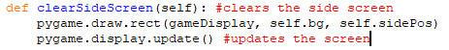

##### Objective 9: Viewing players properties

Whilst programming this game, I have realised that it is very hard to keep track of the players properties, therefore I thought it would be a good idea before players take their turns, to give them the choice if they would like to see the list of their properties

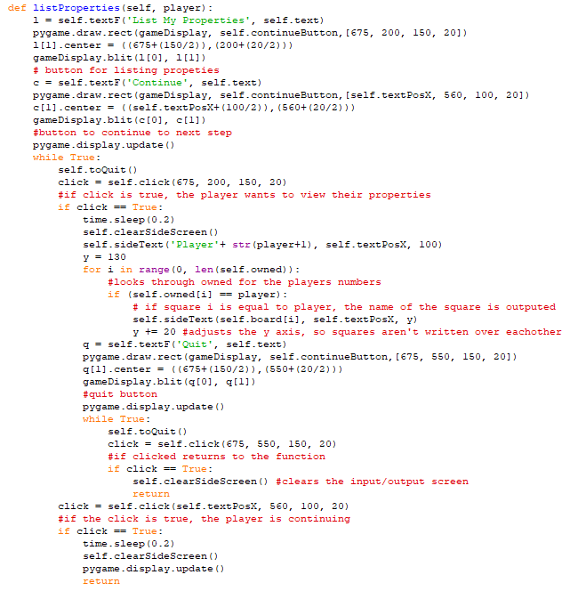

##### Objective 10: When Landing on a Square

I have kept the process the same in the temptations, companies, and candySquares functions, however when they buy the squares, they answer by clicking a yes or no button:

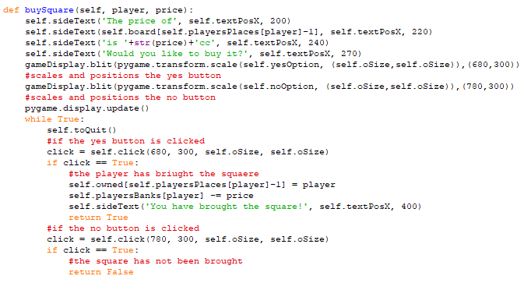

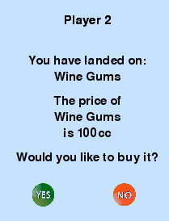

Illustration 8: Landing on a square

##### Objective 11: Landing on an owned square

When a player lands on a company and temptation that is owned by another player, they do the same process they would do in the simple program however, they use the GUI functions for example instead of print, self.sideText is used:

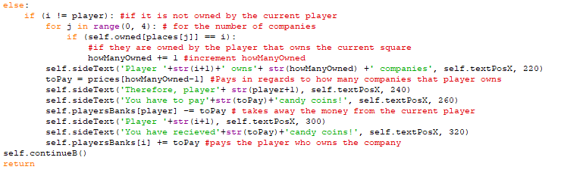e.g. for companies:

However in candy squares, if a player lands on one, images of how many bags/tubs there are on that square is displayed, this is done by:

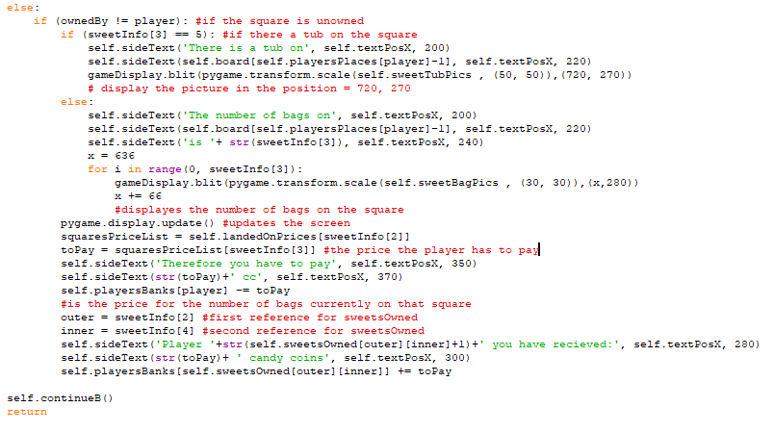

##### Objective 12: Adding Bugs/Tub to a Square

At the beginning of every turn the program checks If a player can add any bags/tubs to their squares, this can only happen when that player owns all candy squares of the same colour.

I have adapted the beginning of my addBagsTubs function so that if a colour group of candy squares all have a tub on them they are not given as an option to add another bag as these squares are full:

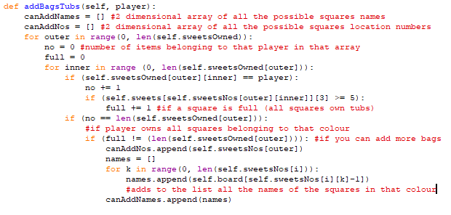

If the player does own squares of the same colour and they are not full, they are given the choice if they would like to buy the square or not, with yes or no buttons:

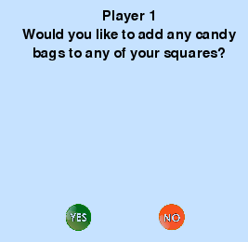

Illustration 9: Yes/No buttons

If yes is pressed – it goes to the function option:

1. The list of options are outputted as buttons
2. Chooses option by clicking on it
3. If quit is clicked – returns to function
4. If tub was added
   1. The tub image is shown
5. If a bag was added
   1. 1-4 bags are displayed

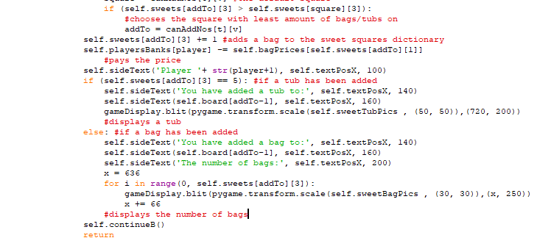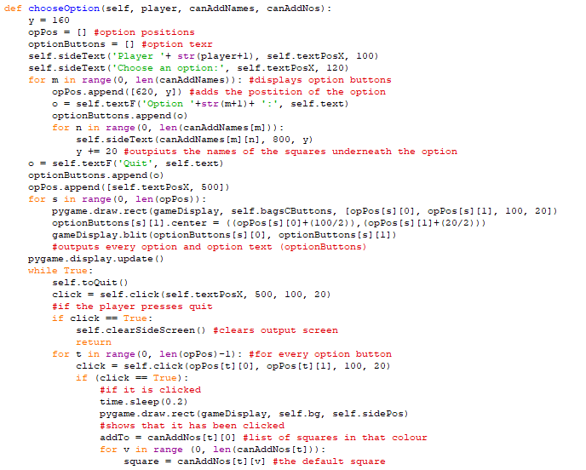

##### Objective 13: Get out of Dentist

When the player is in the dentist they are given 3 options:

1. Pay 50
2. Roll a double
3. Use a card

In this program If a player does not own a card, this will not be an option for them.

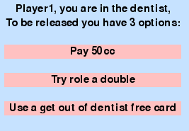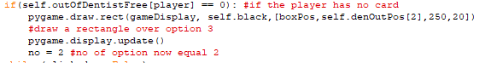In the GUI I will create a button for each option however, if the player foes not have the card the 3rd option button will not be active:

When there is a get out of dentist free card:

When there is not a get out of dentist free card:

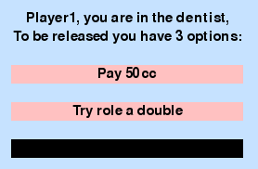3rd option is not active and cannot be clicked

Illustration 10: Dentist cards

##### Objective 14: When a player has gone Bankrupt or Won

As you will see in the testing, every time a program is run the current player is tested to see if they are bankrupt, if they are they are removed from the game. Once all players bar one is removed the game is over and the remaining player is the winner.

## Testing

In this testing I’m going to play a whole game doing normal, boundary and erroneous tests.

### Test Plan

#### Table 10: Test Plan

|  |  |  |  |  |
| --- | --- | --- | --- | --- |
| No | Input Data | Expected output | Objective | Comment |
| 1 | Import Pygame | *No error* | 3 | To test that Pygame has been downloaded correctly |
| 2 | *Run the game* | *Correct screen layout* | 4 | Test to see if the screen output is correct, with the board being outputted correctly |
| 3.1 | *2 players* | *2 counters appear on go* | 5 | To test if when a players button is pressed the counters are placed on the board |
| 3.2 | 2 players | There are currently 2 players  Players banks:  Player 1 = 1500cc  Player 2 = 1500cc | 5 | To test to see if correct number of players are shown after the no of players button is pressed and to see if all players banks are set to 1500cc |
| 3.3 | 10 players | *not an option* | 5 | To text to see if an invalid no of players was clicked |
| 4.1.1 | 4 players | Player …  *Property1*  *Property2*  Quit *button* | 9 | To see if when the option to view the players list of properties is clicked, a list of properties outputted |
| 4.1.2 | 2 players  *Quit button* | *Returns to main program* | 9 | To see if when the player is done looking at the properties, they can press quit and go back to playing the game |
| 4.2 | 5 players  *Continue button* | *Continues to roll the dice* | 9 | To see if the program continues rather than viewing a list of their properties |
| 5 | *Click dice* | Dice 1 = …  Dice 2 = …  Move … Places! | 6 | To test when the dice button is clicked, 2 dice are calculated and output to the side screen |
| 6 | *Click dice* | You have rolled a double, therefore you get another turn | 6a | To test what happens when a double is rolled |
| 7 | *Click dice* | *The counter should move the number on the dice around the board* | 8 | To see if the counters move the correct number of positions around the board depending on the dice |
| 8 | *Click dice* | You have passed Go!  You have collected 200cc! | 8b | To see if the player collects 200cc when they pass go |
| 9 | *Click dice* | You have landed on….. | 10 | To see if when a player lands on a square, the name of the square is displayed |
| 10.1 | *Yes button* | Would you like to buy it?  *yes*  You have brought the square | 10 | To see if the player can use the yes button to answer a question and have the correct output |
| 10.2 | *No button* | Would you like to buy it?  *yes*  Continue | 10 | To see if the player can use the no button to answer a question and have the correct output |
| 11 | *Dice button* | You have landed on: Cotton Candy Card  Your card: …………..  *Completes action* | 10 | To test if the program still works when a program lands on a cotton candy card |
| 12 | *Dice button* | You have landed on: Free Candy  You have collected …. Candy coins!  *Their bank must add the collected money* | 10 | To test if to see if the candy coins are collected from free candy when a player lands on it |
| 13 | *Dice button* | You have landed on: bills  You have to pay your bills, pay 100cc | 10 | To test if the program still works when a program lands on a bill |
| 14 | *Dice button* | You have landed on: Go to the dentist  You have been sent to the dentist  *The counter should move to the dentist* | 10 | To test if the program still works when a program lands on ‘Go to the dentist’ |
| 15.1 | *Yes button* | You have landed on:  The price of … is …  Would you like to buy it?  You have brought the square | 11 | To test if the program gives the user an option if they land on an unowned temptation to buy it - yes |
| 15.2 | *No button* | You have landed on:  The price of … is …  Would you like to buy it?  continue | 11 | To test if the program gives the user an option if they land on an unowned temptation to buy it - no |
| 16.1 | *Yes button* |  | 11 | To test if the program gives the user an option if they land on an unowned company to buy it - yes |
| 16.2 | *No button* | continues | 11 | To test if the program gives the user an option if they land on an unowned company to buy it - no |
| 17.1 | *Yes button* | You have brought the square | 11 | To test if a non-owned candy square is landed on, it allows the user to buy it if they click yes |
| 17.2 | *No button* | *continues* | 11 | To test if a non-owned candy square is landed on, the user can not buy it by clicking no |
| 18.1 | *Click Pay 50cc* | You’ve paid 50cc and are now released from the dentist! | 13 | To test to see if the user can pay 50cc to be released from the dentist if they click the button |
| 18.2 | *Click Try roll a double*  *Roll dice* | Dice 1 =  Dice 2 =  You’ve rolled a double! And are now released from the dentist! | 13 | To see if when a user chooses to try roll a double and does they can be released from the dentist |
| 18.3 | *Click Try roll a double*  *Roll dice* | Dice 1 =  Dice 2 =  You have not rolled a double, therefore, are not released from the dentist | 13 | To see if when a user chooses to try roll a double but does not roll one |
| 18.4 | *Click use a get out of dentist free card* | Player .. you are in the dentist:  To be released you have 3 options :  Pay 50cc  Roll a double  Use a get out of dentist free card  You have used one of your cards and are released from the dentist | 13 | To see if when a user has a get out of the dentist free card and it is used, they can be released from the dentist |
| 18.5 | *none* | Player .. you are in the dentist:  To be released you have 3 options :  Pay 50cc  Roll a double | 13a | To see if when a user does not have a get out of the dentist free card |
| 19.1 | *Roll dice* | You have landed on…  The number of bags on… is 0  Player… you have received … cc  Therefore you pay ….cc | 11 | To test if when a player lands on a candy square that is owned that it pays the correct amount of money when there are no bags on it |
| 19.2 | *Roll dice* | You have landed on..  The number of bags on .. is (1-4)  Player .. you have received … cc  Therefore you have to pay cc | 11 | To test if when a player lands on a candy square that is owned that it pays the correct amount of money when there is bags on it |
| 20 | *Roll dice* | You have landed on…  Player .. owns … temptation  Therefore you pay … times the amount shown on the dice = ..  Player… you have received … cc | 11 | When a player lands on a players square which owns one or both temptations, they must pay the correct amount of money to the other player (4 or 10 times the number on the dice) |
| 21 | *Roll dice* | You have landed on:…..  Player … owns … companies  Therefore player ….  You have to pay .. cc  Player… you have received ….cc | 11 | When a player lands on a players square which owns more than one company, they must pay the correct amount of money to the other player |
| 22 | *Roll dice* | You have landed on..  Continue | 11 | To test what will happen when a player lands on a square that they own |
| 23.1 | *Have all squares of a particular colour* | Player….  Would you like to add any candy bags to any of your squares? | 12 | To see if a player is asked to add any bags to their squares once they have all the squares of a colour |
| 23.2 | Click yes  Click an option | You have added a bag to ….  The number of bags = …. | 12 | Test to see if a player can click on an option and add a bag to a square |
| 23.3 | *Click option* | Sorry you have the max number of tubs on that colour squares! | 12 | Test to see that once there is a tub on every square of that colour, no more can be added |
| 24 | none | Player .. has gone bankrupt  Therefore are out of the game | 14 | To test to see if when a player goes bankrupt, this is displayed to the user and they are out of the game and miss their goes |
| 25 | *none* | Player… has won the game! | 14 | To test when all but one player has gone bankrupt, that there is a winner and the game ends |

### Test Log

#### Table 11: Test Log

|  |  |  |
| --- | --- | --- |
| No | Actual Output | Correct? |
| 1 |  | yes |
| 2 |  | yes |
| 3.1 |  | yes |
| 3.2 | Top of the screen  bottom of the screen | yes |
| 3.3 | There is only 5 buttons ranging from 2-6 players, therefore no option | yes |
| 4.1.1 | …. | yes |
| 4.1.2 | Pressed quit and moved on to player 2’s turn | yes |
| 4.2 | 🡪 | yes |
| 5 |  | yes |
| 6 | They have their first go then, this screen displays and they roll again | yes |
| 7 | (from go) | yes |
| 8 | -> | yes |
| 9 |  | yes |
| 10.1 |  | yes |
| 10.2 |  | yes |
| 11 |  | yes |
| 12 |  | yes |
| 13 |  | yes |
| 14 |  | yes |
| 15.1 |  | yes |
| 15.2 |  |  |
| 16.1 |  | yes |
| 16.2 |  | yes |
| 17.1 |  | yes |
| 17.2 |  | yes |
| 18.1 |  | yes |
| 18.2 |  | Yes |
| 18.3 |  | yes |
| 18.4 |  | yes |
| 18.5 | Cannot click on the 3rd option | yes |
| 19.1 |  | yes |
| 19.2 |  | Yes however, the positioning of the bag is incorrect |
| 20 |  | yes |
| 21 |  | yes |
| 22 |  | yes |
| 23.1 |  | yes |
| 23.2 |  | yes |
| 23.3 | I was unable to get this test as the program never got as far as going past having tubs on every square of that colour | no |
| 24 |  | yes |
| 25 |  | yes |

#### Full Screen Tests

This test is to mostly show if the counters move round the board the correct number of positions (dice) and to show the players banks changing:

(4 players)

Illustration 11: Full Screen Tests

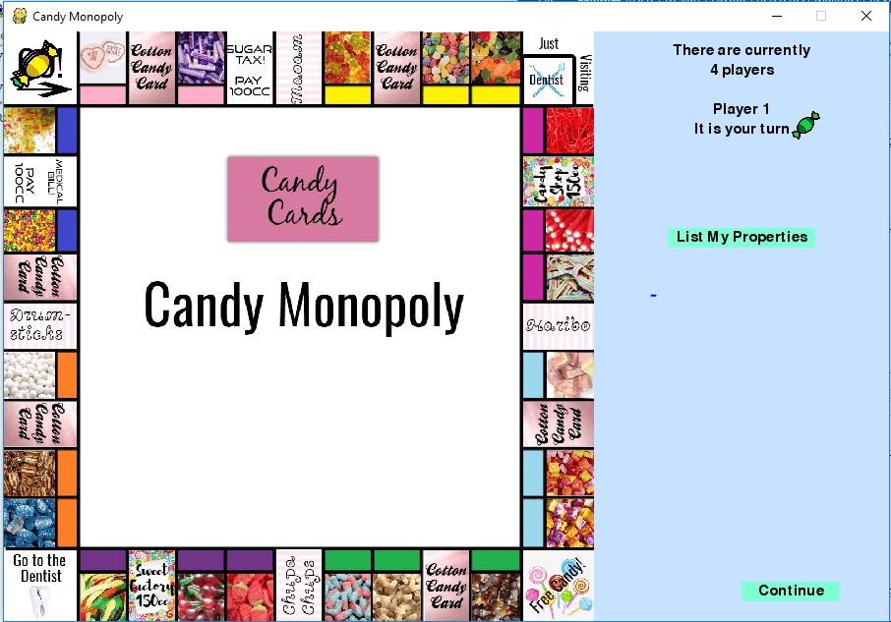

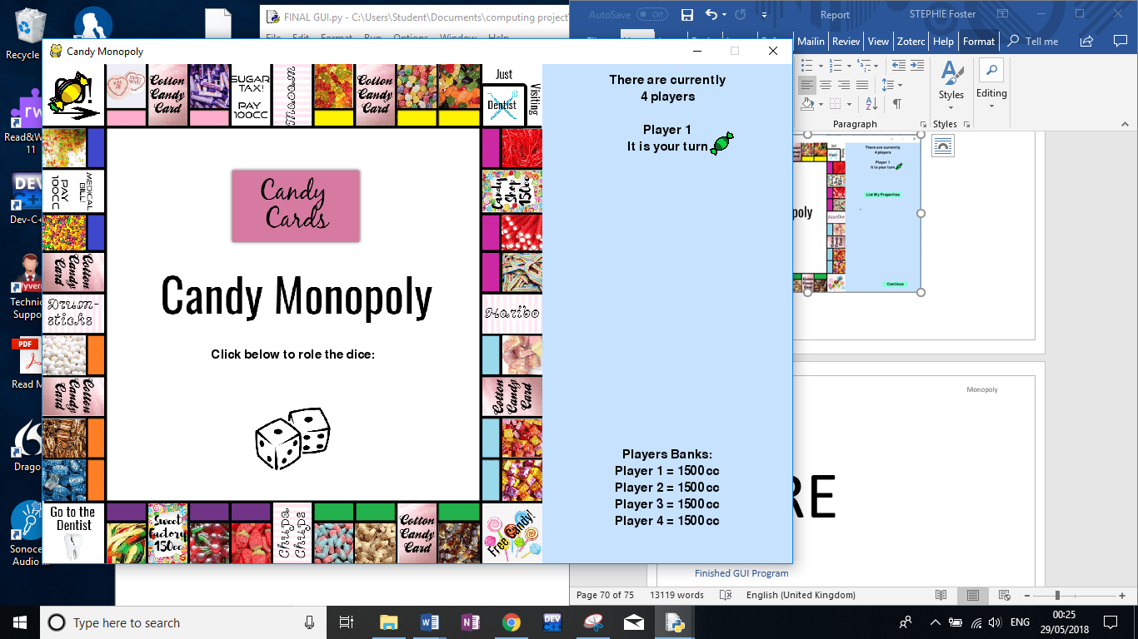

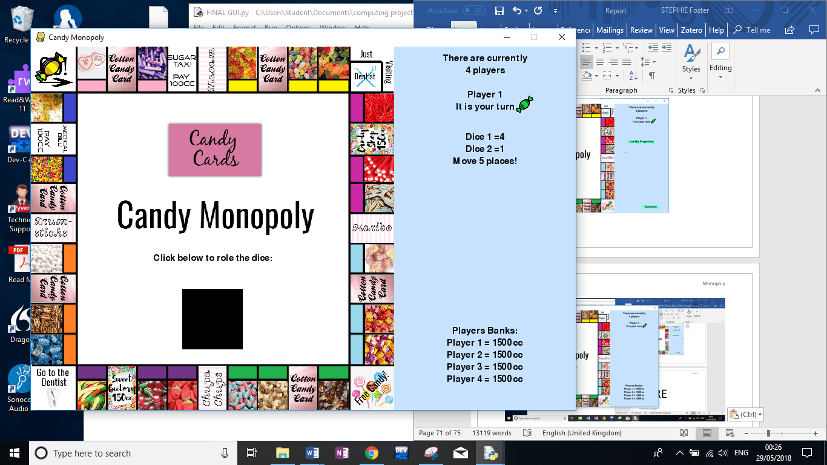

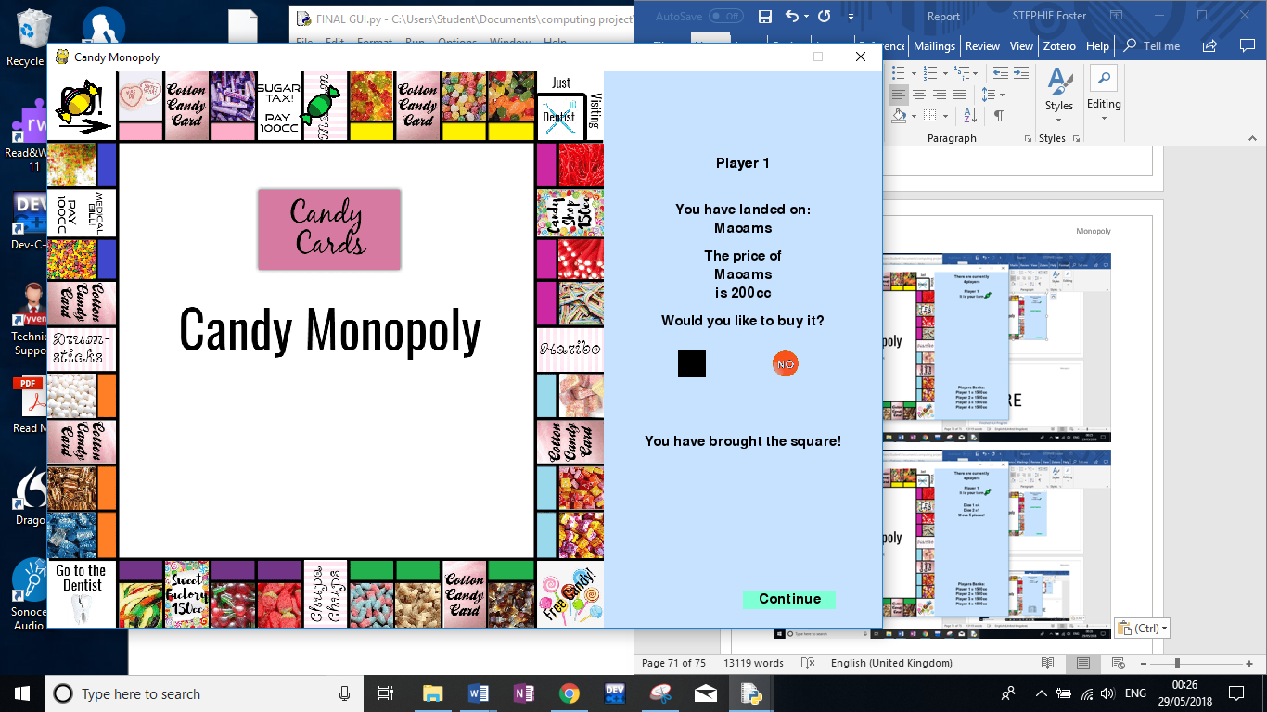

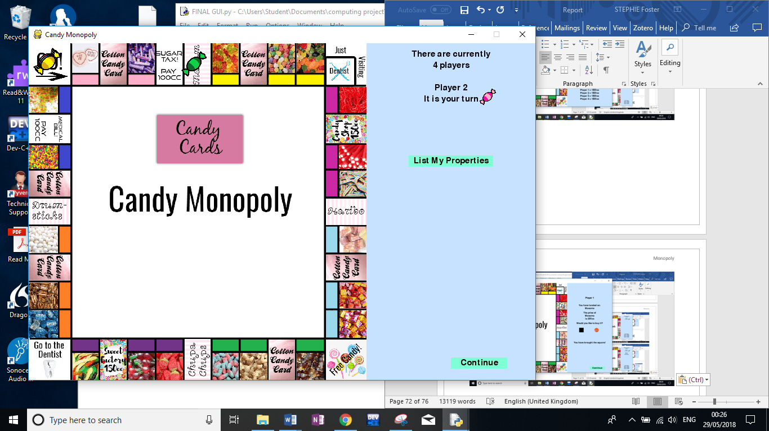

Dice = 7

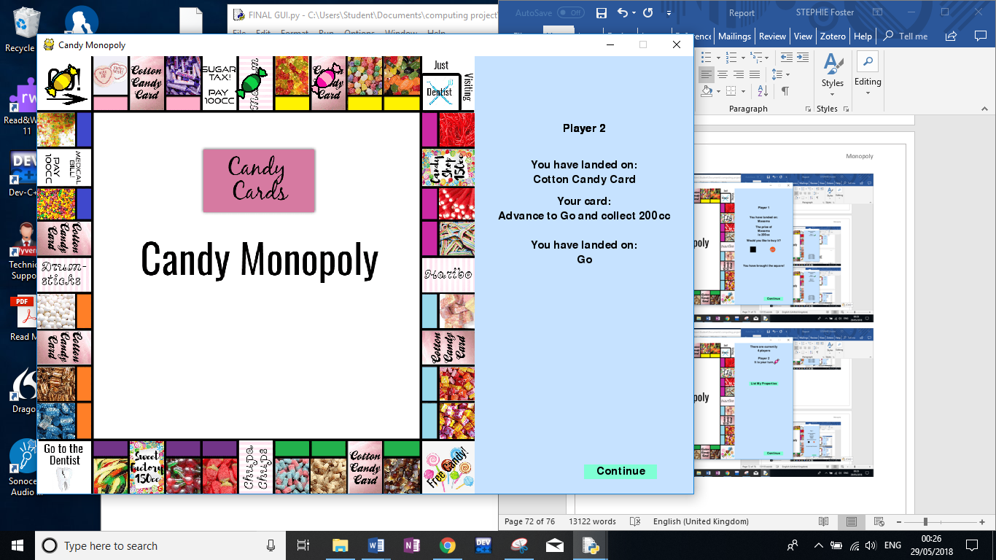

# Evaluation

In evaluation, I used my simple program as a base program then added the GUI functions to it and changed some statements around to create this GUI. The simple program included a lot more validation than the GUI as it was not as vital as if an option wasn’t possible, the game would not give the player the option in the first place. By looking through my objectives for my GUI program I will evaluate the extent to which I met each objective and identify any ways in which the simple program could be improved.

**Objective 1: Do some research into Pygame, so I have more of an understanding of what it is**

I believe I could’ve done more extensive research on Pygame at the beginning, however my understanding has increased. Whilst I was creating the GUI I was researching Pygame, looking at how to use certain functions and seeing if they would help create the GUI., which was very helpful as I have never used Pygame before.

**Objective 2: Design and create an original board, as well as collect images for counters, bags, tubs.**

Objective 2 has been met in full; I have created a board from scratch to represent the candy monopoly board, in the program the board, counters, bags and tubs are all used effectively. To improve on the design a bit more I would make the company names easier to read.

**Objective 3: Download the Pygame module, so it can be used in the program**

This has been fully met, this objective took me a lot longer than it should’ve done, I looked up many ways to download it however they didn’t work, until I found the answer in stack overflow, which worked immediately.

**Objective 4: Create the GUI screen, which contains the created board**

I have fully met this objective, as you can see in testing, a screen is created with the candy monopoly board, the title of ‘Candy Monopoly’ and a side bar that will contain all the inputs(button presses) and outputs.

**Objective 5: Update players, so the user clicks on a button to decide the no of players (only 2-6 players allowed), it should be displayed to the user that all players start off with 1500cc**

This objective has been fully met; at the start of the program the user is asked for the number of players, with 5 buttons; 2 players, 3 players… up to 6 players. There does not need to be any validation here as the only valid buttons are available to the user. The banks are set at 1500cc for every player and is displayed before the player rolls a dice.

**Objective 6: The users must be able to click on a button to roll the dice, where the total dice must be calculated and displayed to the user**

* 1. **If they get a double the player gets to roll again**

Near the beginning of the game the user is asked to roll the dice, the dice button is located on the middle of the board, when it is clicked, the 2 dice values are outputted along with the total. If a player rolls a double, after their 1st go is complete this is displayed to them that they have rolled a double therefore get another go, the player then has another go and the game carries on. Therefore objective 6 has been fully met.

**Objective 7: To find a way to store the squares positions on the board**

This objective has been fully met; I have represented the board in a two dimensional array, where each square number contains the x and y coordinate, this also helped a lot for objective 8.

**Objective 8: Allow the counters to be used in the GUI where they must be allowed to move around on the board by the total of the dice**

1. **If they pass go 🡪 collect 200cc**
2. **What square they’ve landed on must be displayed**

Using the board, created in objective 7, objective 8 has been fully met. The board positions variable allows the players to get from square to square by using the playersPlaces[player] variable as a reference. I have also added on an extension for each counter, so they are all a couple of axis off each other, therefore if one counter is on a square with another, both counters can be seen, without this it would look like there is one counter on a square when there could be up to 6.

**Objective 9: Before every go the player must asked if they would like to see a list of their properties or continue**

1. **List of their properties = any square that they own**

Before every turn a button called List Properties appears, if it is clicked, it lists all the properties owned by the current player, if not, the continue button can be used to move on to rolling the dice etc. As you can see in my testing this works and the objective has been fully met.

**Objective 10: When a player lands on an unowned square the said action must take place**

1. **If the action requires an answer, the user is asked and there are appropriate buttons to allow the user to make the decisions.**

This objective was met by just changing the buySquares to allow users to buy companies, temptations and candy squares (the only squares that can be unowned) if they are unowned. I changed buySquares so the player would answer with the yes or no buttons, which did not need to be validated as they were the only 2 options available.

**Objective 11: When a player lands on an owned square the player must pay the appropriate amount to the player who owns that square**

When a player lands on an owned square, the process has a minor change from the simple program as it takes no user input (except the roll of the dice). Therefore I only had to tweak minor aspects to meet this objective fully.

**Objective 12: If the current player has all the candy squares of the same colour, they must be given the option (yes/no button) to add any bags or tubs to a square**

1. **Same rules apply for adding bags – one at a time etc.**

At the beginning of every turn the program checks if the player can add the bags/tubs to their squares. If they can, they are asked if they would like to by using buttons yes and no. If yes is chosen, only valid colour options are outputted to the screen along with the candy square names, an option is then chosen by clicking on the option button. When bags are brought they are displayed on the buying screen. If no the program continues. My code and testing for this part of the program shows that the objective has been fully met.

**Objective 13: When a player is in the dentist, they are still given 3 options (buttons)**

1. **Cannot click on ‘Use a get out of dentist free card’ if it is not owned**

This objective has been fully met; If the player does not own a get out of the dentist free card, there will be no option, therefore will have to choose out of the other 2 options and the 3rd button will be inactive. There doesn’t have to be any extra validation to this as all other options are valid. If the player chooses to try to roll a double, they are taken back to the roll dice page, if it is a double they are released, if not they miss another go.

**Objective 14: Every time the program is run, it must check if a player has gone bankrupt (therefore misses a go), and if there is a winner (the rest of the players are bankrupt)**

Fully met; as at the end of every go, the program still checks if the user is bankrupt and if they are they are out of the game. At the beginning of every turn the program checks to see if there is a winner by seeing if all players apart from one is bankrupt, if this is true that player has won the game and the game ends.

Throughout my GUI program, I was stuck a lot as I have never programed with Pygame before, however with further research into Pygame throughout implementation, a lot of problems were solved and more ideas came. The success of my objectives allows me to move onto my development of the computer player. To improve this program I would set out the order of the functions differently as well as splitting functions up as they are very long, I would have also put different functions into different classes where it would make sense, so the code is easier to follow.

# The Computer Player GUI

## Introduction

In this program I am going to be creating a computer player, that the other users can play against using the GUI. I am going to think of a way where it is hard for the computer player to loose the game therefore making it a good opponent for players. The computer player will use the GUI as well as the human players and their moves will be shown to the user. This program will also stick to the rules and criteria of the Candy Monopoly.

## Plan

I will be planning how the computer player will decide on the options given throughout the game, how complicated and thought out these decisions are will depend on how long I have left to complete the project. I will be updating the GUI program where when a decision is made, if the player is the computer player certain conditions will have to be met to go with that decision. After implementing the computer GUI I will effectively test the program then write an evaluation. After I have finished this program I am going to test the games on some users to get their feedback.

### Objectives

1. Find ways for how the computer player is going to make decisions throughout the game
2. The human players need to be asked for the number of human players with the computer player
   1. There will be 5 buttons 1-5
3. The game will work like the original GUI for the human players
4. The computer player should simulate
   1. Rolling the dice
   2. Clicking continue/quit
5. Before every go the human players should be allowed to view their properties as well as the computer players properties
6. Wherever a decision must be made there needs to be conditions to decide whether to go with yes or no etc.
   1. Whenever the computer player lands on an unowned square
      1. Temptations
      2. Companies
      3. Candy squares
   2. To add any bags/tubs
7. The computer player must decide what option it will choose to attempt to be released from the dentist
8. Every time the program is run, it must check if a player has gone bankrupt (therefore misses a go), and if there is a winner (the rest of the players are bankrupt)

­­­­­­­­­­

### My Approach

The computer player will be set to player 1 every time.

##### Computer player conditions that are used for making decisions:

For buying an unowned company:

* If the computer player already owns 2 or more 🡪 yes
* If the computer players bank is over 500cc 🡪 yes
* Else 🡪 no

For buying an unowned temptation:

* If already owns one 🡪 yes
* If the computer players bank is over 500cc 🡪 yes
* Else 🡪 no

For buying an unowned candy square

* Does it already ownb another square with that colour
  + If yes 🡪 yes
* If the computer players bank is over 600cc 🡪 yes
* Else 🡪 no

When adding bags/tubs to a square

* If the computer players bank is over 500cc 🡪 yes
* Else 🡪 no

When escaping from the dentist

* If owned use a get out of jail free card
* If their bank is less than 100, attempt to roll a double
* Else, pay the 50cc

I think my ideas above are very effective as it will be very hard for the player to go bankrupt, the player will never loose money intentionally, however they may loose by landing on other squares in which they have to pay.

##### To simulate that there is a computer player

Add in time.sleep() to add in pauses after the computer player has completed an action, therefore the human players can see its move clearly and it may feel more realistic.

Whenever a decision is make the button is made to look like it is being clicked by placing the black square over the button and pausing for a couple of seconds

## Implementation

##### Functions in the computer GUI program

I will be adding to the functions that were created in the GUI program, from the computer player program as I go along. I will not include functions already defined in the GUI program

|  |  |  |
| --- | --- | --- |
| Name | Which class | Why is it used/what is returned(if anything) |
| printsAdd | Main | When the player adds bags/tubs to a square (slip off from original chooseOption) |
| compBuySquare | Main | Finds out if the computer player wants to buy one of the squares – temptations, companies or a candy square |
| visitingProperties | Main | Creates a list of the players properties and outputs them to the screen |

##### Objective 2: Number of players + computer player

Instead of having buttons 2-6, I am going to create the buttons 1-5 + the computer player, which will always be player 1. To implement this I will just need to change one of the for loops:

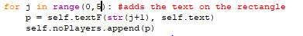

##### Objective 3: No change in the GUI for the human players

Throughout implementation I will keep the GUI the same for the human players, I am planning on adding if and else statements in:

* If player = computer player 🡪 do this
* Else 🡪 do the human player GUI way

##### Objective 4: Computer Player Rolling the dice and Continuing

To simulate the rolling of the dice and clicking continue I am going to ….

* Use the time library with the method sleep for natural pauses whenever there is a decision in the program
* Then draw a rectangle over the square so it looks like the dice has been clicked on.

Rolling the dice:

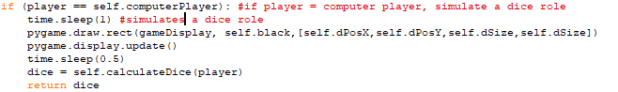

Clicking continue

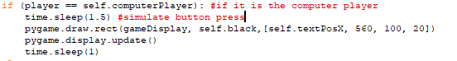

##### Objective 5: View Properties

Before every human go, they get to choose if they want to view their properties, the computers properties or move on. I decided to have a separate function that listProperties calls to when the player wants to view the human or computer properties,

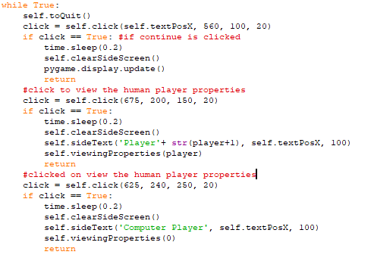

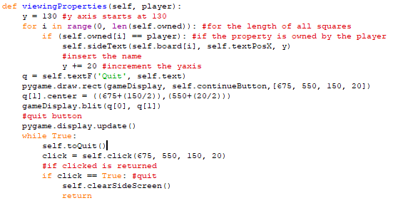

##### Objective 6: Decisions Made, to buy a square, to add any bags/tubs

When landing on a Temptation, Company or Candy square that is unowned, instead of going to buySquare it goes to the new function compBuySquare

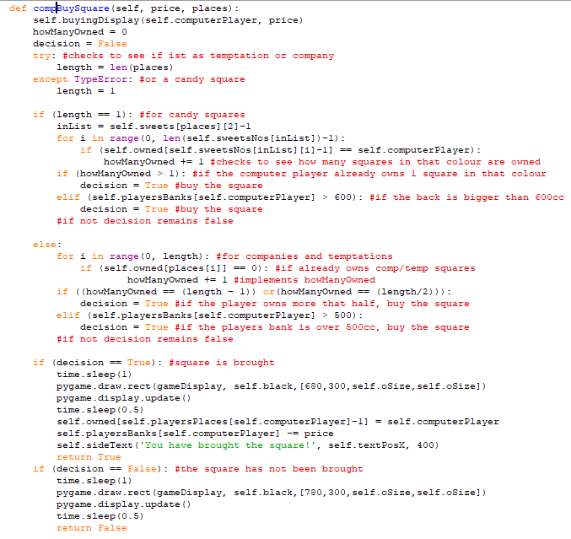

When adding a bag/tub to a square

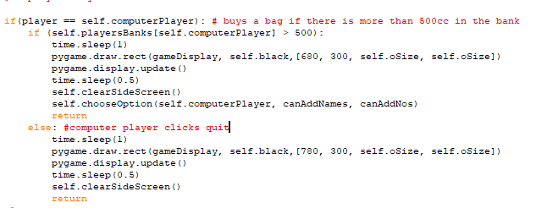

##### Objective 7: Computer player dentist option

The computer player will…

1. Check if they own a get out of denstisr free card
   1. Yes use this 🡪end
2. If players bank < 100
   1. Role double 🡪 end
3. Else
   1. 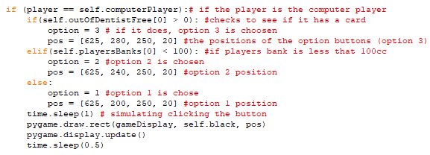Pay 50cc

##### Objective 8: When there is a winner

Every time the program is run, it must check if a player has gone bankrupt (therefore misses a go), and if there is a winner (the rest of the players are bankrupt)

## Test Plan

|  |  |  |  |  |
| --- | --- | --- | --- | --- |
| No | Input Data | Expected Output | Objective | Comment |
| 1 | 2 player click | There are currently 3 players | 2a | To see if the button numbers are outputted correctly and to test the correct number of players are playing |
| 2.1 | 2 player click  Continue  Role dice | Dice 1 = ..  Dice 2 = …  Move … Places  ….  You have landed on…  *Action takes place* | 3 | To test id everything is the same for the human player |
| 2.2 | 4 player click  Continue  Role dice |  | 3 | Another test to show everything is still ok for human players |
| 3 | 2 player | *Player 1 roles the dice*  *Player 1 clicks continue* | 4 | To see if the computer player simulates a role of the dice and the click of the continue button |
| 4.1 | List My Properties | *human players properties* | 5 | To see if the correct properties are listed for the human player |
| 4.2 | List computer players properties | *Computer players properties* | 5 | To see if the correct properties are listed for the computer player |
| 5.1 | *none* | *P1 clicks yes*  *Clicks continue* | 6 | Test to see what happens when a computer player lands on a temptation or a company |
| 5.2 | *none* | *P1 clicks yes*  *P1 clicks continue* | 6 | Test to see what happens when a computer player lands on a candy square |
| 5.3 | *none* | *Player 1 choose an option*  *…*  *You have added a bag to…*  *Number of bags =* | 6 | Test to see what happens when a computer player can add bags/tubs to squares |
| 6 | *none* | *Player one will choose pay50 unless it has a out of dentist free card or its bank is less than 100cc* | 7 | Attempt chosen when the computer player is sent to the dentist |
| 7 | none | Player …. Has gone bankrupt and is out of the game  Player 1 has won the game | 8 | To see what happens when a player goes bankrupt and there is a winner |

## Test Log

|  |  |  |  |
| --- | --- | --- | --- |
| No | Actual Output | Correct? | |
| 1 |  | yes | |
| 2.1 |  | yes | |
| 2.2 |  | yes | |
| 3 |  |  | |
| 4.1 |  | yes | |
| 4.2 |  | yes | |
| 5.1 |  | yes | |
| 5.2  And  3 |  | | Yes |
| 5.3 |  | yes | |
| 6 |  | yes | |
| 7 |  | yes | |

## Evaluation

By looking through my objectives from my computer player program I will evaluate the extent to which I met each objective and identify anyways in which the program could be improved. In this program I added to the GUI however, I have started to run short of time therefore I was a bit rushed with the testing and behind with the write up.

1. Find ways for how the computer player is going to make decisions throughout the game

Objective one was met in full as for every decision a player would have to make, the computer player would make these decisions based on conditions that I have designed to make the computer player a strong competitor.

1. The human players need to be asked for the number of human players with the computer player
   1. There will be 5 buttons 1-5

This object was met in full as at the beginning of the game the human player is assekd for the number of human players plus a computer player, therefore the buttons rnaged from 1 to 5 instead of 2 to 6.

1. The game will work like the original GUI for the human players

This objectjextive was met in full as the human players were allowed to play the game as usual, as shown in the testing, as the code for the computer player was separate from the human player.

1. The computer player should simulate
   1. Rolling the dice
   2. Clicking continue/quit

This objective was met in full as when the computer player is meant to be pressing a button, I used time.sleep() and pygame.draw.rect() to simulate a button be pressed, when a button is clicked the button is coverd with a black retangle for a couple of seconds then the program moves on to completes that action from the button it has pressed, therefore I did an oline simulation of this happening whenever the computer player is meant to press a button.

1. Before every go the human players should be allowed to view their properties as well as the computer players properties

This object was also met in full as before the human players rolled the dice they get an option to view their properties or the computer players properties, which when clicked on - outputs all the properties that player owns, The other option is to continue to the human pllayers go.

1. Wherever a decision must be made there needs to be conditions to decide whether to go with yes or no etc.
   1. Whenever the computer player lands on an unowned square
      1. Temptations
      2. Companies
      3. Candy squares
   2. To add any bags/tubs

I had programmed in certain conditions when buying a square or adding a bag, if the player passes those conditions they can buy the square, if not, they cannot. Therefore this objective was met in full.

1. The computer player must decide what option it will choose to attempt to be released from the dentist

This objective was also met in full as when the computer player trys to get released from the dentsit, particular options are favoured over others, e.g. beign released with a get out of dentsist free card. Over rolling a doule

1. Every time the program is run, it must check if a player has gone bankrupt (therefore misses a go), and if there is a winner (the rest of the players are bankrupt)

The final objective, was fully met; as at the end of every go, the program checks if the user is bankrupt and a variable called lost is incremented if they are. At the beginning of every turn the program checks to see if there is a winner by seeing if all players apart from one is bankrupt, if this is true that player has won the game. This is also displayed to the user as you can see in my testing.

I was near the end of the deadline for the project therefoe my program and write up for the computer player were of a lower standard of work compared to my other programs and write I had produced. However I have succeeded with all of the objectives, although there are lots of things I could improve in this program e.g. not having such long functions, improve on the testing and I could’ve made the computer player a lot smarter if there were time.

# The Computer Player GUI

## Introduction

In this program I am going to create a computer player, that other users can play against using the GUI. I am going to think of a way where it is hard for the computer player to lose the game therefore making it a good opponent for players. The computer player will use the GUI as well as the human players and the computer moves will be shown to the user. This program will also stick to the rules and criteria of the Candy Monopoly.

## Plan

I will be planning how the computer player will decide on the options given throughout the game, how complicated and thought out these decisions are will depend on how long I have left to complete the project. I will be updating the GUI program where when a decision is made, if the player is the computer player certain conditions will have to be met to go with that decision. After implementing the computer GUI I will effectively test the program then write an evaluation. After I have finished this program I am going to test the games on some users to get their feedback.

### Objectives

1. Find ways for how the computer player is going to make decisions throughout the game
2. The human players need to be asked for the number of human players with the computer player
   1. There will be 5 buttons 1-5
3. The game will work like the original GUI for the human players
4. The computer player should simulate
   1. Rolling the dice
   2. Clicking continue/quit
5. Before every go the human players should be allowed to view their properties as well as the computer players properties
6. Wherever a decision must be made there needs to be conditions to decide whether to go with yes or no etc.
   1. Whenever the computer player lands on an unowned square
      1. Temptations
      2. Companies
      3. Candy squares
   2. To add any bags/tubs
7. The computer player must decide what option it will choose to attempt to be released from the dentist
8. Every time the program is run, it must check if a player has gone bankrupt (therefore misses a go), and if there is a winner (the rest of the players are bankrupt).

­­­­­­­­­­

### My Approach

The computer player will be set to player 1 every time.

##### Computer player conditions that are used for making decisions:

For buying an unowned company:

* If the computer player already owns 2 or more 🡪 yes
* If the computer players bank is over 500cc 🡪 yes
* Else 🡪 no

For buying an unowned temptation:

* If already owns one 🡪 yes
* If the computer players bank is over 500cc 🡪 yes
* Else 🡪 no

For buying an unowned candy square

* Does it already own another square with that colour
  + If yes 🡪 yes
* If the computer players bank is over 600cc 🡪 yes
* Else 🡪 no

When adding bags/tubs to a square

* If the computer players bank is over 500cc 🡪 yes
* Else 🡪 no

When escaping from the dentist

* If owned use a get out of jail free card
* If their bank is less than 100, attempt to roll a double
* Else, pay the 50cc

I think my ideas above are very effective as it will be very hard for the player to go bankrupt, the player will never lose money intentionally, however they may lose by landing on other squares in which they have to pay.

##### To simulate that there is a computer player

Add in time.sleep() to add in pauses after the computer player has completed an action, therefore the human players can see its move clearly and it may feel more realistic.

Whenever a decision is make the button is made to look like it is being clicked by placing the black square over the button and pausing for a couple of seconds.

## Implementation

##### Functions in the computer GUI program

I will be adding to the functions that were created in the GUI program, from the computer player program as I go along. I will not include functions already defined in the GUI program

#### Table 12: Functions in the computer GUI program

|  |  |  |
| --- | --- | --- |
| Name | Which class | Why is it used/what is returned(if anything) |
| printsAdd | Main | When the player adds bags/tubs to a square (slip off from original chooseOption) |
| compBuySquare | Main | Finds out if the computer player wants to buy one of the squares – temptations, companies or a candy square |
| visitingProperties | Main | Creates a list of the players properties and outputs them to the screen |

##### Objective 2: Number of players + computer player

Instead of having buttons 2-6, I am going to create the buttons 1-5 + the computer player, which will always be player 1. To implement this I will just need to change one of the for loops:



##### Objective 3: No change in the GUI for the human players

Throughout implementation I will keep the GUI the same for the human players, I am planning on adding if and else statements in:

* If player = computer player 🡪 do this
* Else 🡪 do the human player GUI way

##### Objective 4: Computer Player Rolling the dice and Continuing

To simulate the rolling of the dice and clicking continue I am going to ….

* Use the time library with the method sleep for natural pauses whenever there is a decision in the program
* Then draw a rectangle over the square so it looks like the dice has been clicked on.

Rolling the dice:



Clicking continue



##### Objective 5: View Properties

Before every human player go, they get to choose if they want to view their properties, the computers properties or move on. I decided to have a separate function that listProperties calls to when the player wants to view the human or computer properties,





##### Objective 6: Decisions Made, to buy a square, to add any bags/tubs

When landing on a Temptation, Company or Candy square that is unowned, instead of going to buySquare it goes to the new function compBuySquare



When adding a bag/tub to a square



##### Objective 7: Computer player dentist option

The computer player will…

1. Check if they own a get out of dentist free card
   1. Yes use this 🡪end
2. If players bank < 100
   1. Roll double 🡪 end
3. Else
   1. Pay 50cc

##### Objective 8: When there is a winner

Every time the program is run, it must check if a player has gone bankrupt (therefore misses a go), and if there is a winner (the rest of the players are bankrupt)

## Test Plan

#### Table 13: Computer GUI Test plan

|  |  |  |  |  |
| --- | --- | --- | --- | --- |
| No | Input Data | Expected Output | Objective | Comment |
| 1 | 2 player click | There are currently 3 players | 2a | To see if the button numbers are outputted correctly and to test the correct number of players are playing |
| 2.1 | 2 player click  Continue  Roll dice | Dice 1 = ..  Dice 2 = …  Move … Places  ….  You have landed on…  *Action takes place* | 3 | To test id everything is the same for the human player |
| 2.2 | 4 player click  Continue  Roll dice |  | 3 | Another test to show everything is still ok for human players |
| 3 | 2 player | *Player 1 rolls the dice*  *Player 1 clicks continue* | 4 | To see if the computer player simulates a roll of the dice and the click of the continue button |
| 4.1 | List My Properties | *human players properties* | 5 | To see if the correct properties are listed for the human player |
| 4.2 | List computer players properties | *Computer players properties* | 5 | To see if the correct properties are listed for the computer player |
| 5.1 | *none* | *P1 clicks yes*  *Clicks continue* | 6 | Test to see what happens when a computer player lands on a temptation or a company |
| 5.2 | *none* | *P1 clicks yes*  *P1 clicks continue* | 6 | Test to see what happens when a computer player lands on a candy square |
| 5.3 | *none* | *Player 1 choose an option*  *…*  *You have added a bag to…*  *Number of bags =* | 6 | Test to see what happens when a computer player can add bags/tubs to squares |
| 6 | *none* | *Player one will choose pay50 unless it has an out of dentist free card or its bank is less than 100cc* | 7 | Attempt chosen when the computer player is sent to the dentist |
| 7 | none | Player …. Has gone bankrupt and is out of the game  Player 1 has won the game | 8 | To see what happens when a player goes bankrupt and there is a winner |

## Test Log

#### Table 14: Computer GUI test log

|  |  |  |  |
| --- | --- | --- | --- |
| No | Actual Output | Correct? | |
| 1 |  | yes | |
| 2.1 |  | yes | |
| 2.2 |  | yes | |
| 3 |  |  | |
| 4.1 |  | yes | |
| 4.2 |  | yes | |
| 5.1 |  | yes | |
| 5.2  And  3 |  | | Yes |
| 5.3 |  | yes | |
| 6 |  | yes | |
| 7 |  | yes | |

## Evaluation

By looking through my objectives from my computer player program I will evaluate the extent to which I met each objective and identify ways in which the program could be improved. In this program I added to the GUI I have started to run short of time therefore I was a bit rushed with the testing and the write up could be better elaborated with more time.

**Objective 1: Find ways for how the computer player is going to make decisions throughout the game**

Objective one was met in full as for every decision a player would have to make, the computer player would make these decisions based on conditions that I have designed to make the computer player a strong competitor.

**Objective 2: The human players need to be asked for the number of human players with the computer player**

1. **There will be 5 buttons 1-5**

This object was met in full as at the beginning of the game the human player is asked for the number of human players plus a computer player, therefore the buttons ranged from 1 to 5 instead of 2 to 6.

**Objective 3: The game will work like the original GUI for the human players**

This objective was met in full as the human players were allowed to play the game as usual, as shown in the testing, as the code for the computer player was separate from the human player.

**Objective 4: The computer player should simulate**

1. **Rolling the dice**
2. **Clicking continue/quit**

This objective was met in full as when the computer player is meant to be pressing a button, I used time.sleep() and pygame.draw.rect() to simulate a button being pressed, when a button is clicked the button is covered with a black rectangle for a couple of seconds then the program moves on to complete that action from the button it has pressed, therefore I did an online simulation of this happening whenever the computer player is meant to press a button.

**Objective 5: Before every go the human players should be allowed to view their properties as well as the computer players properties**

This object was also met in full as before the human players rolled the dice they get an option to view their properties or the computer players properties, which when clicked on - outputs all the properties that player owns, The other option is to continue to the human players go.

**Objective 6: Wherever a decision must be made there needs to be conditions to decide whether to go with yes or no etc.**

1. **Whenever the computer player lands on an unowned square**
   * 1. **Temptations**
     2. **Companies**
     3. **Candy squares**
2. **To add any bags/tubs**

I had programmed in certain conditions when buying a square or adding a bag, if the player passes those conditions they can buy the square, if not, they cannot. Therefore this objective was met in full.

**Objective 7: The computer player must decide what option it will choose to attempt to be released from the dentist**

This objective was met in full as when the computer player tries to get released from the dentist, particular options are favoured over others, e.g. being released with a get out of dentist free card. Over rolling a double.

**Objective 8: Every time the program is run, it must check if a player has gone bankrupt (therefore misses a go), and if there is a winner (the rest of the players are bankrupt).**

The final objective, was fully met; as at the end of every go, the program checks if the user is bankrupt and a variable called lost is incremented if they are. At the beginning of every turn the program checks to see if there is a winner by seeing if all players apart from one is bankrupt, if this is true that player has won the game. This is also displayed to the user as you can see in my testing.

I was near the end of the deadline for the project therefore my program and write up for the computer player were not as thorough compared to my other programs. I have succeeded with all of the objectives, however, there are lots of things I could improve in this program e.g. not having such long functions, improve on the testing and I could’ve made the computer player a lot smarter if there were time.

# Overall Evaluation

Overall I think my project has been a success, I achieved the majority of my objectives. However I also have faced some challenges, in particular my time management, and if I had more time there would be some improvements I would make. By looking through my overall objectives of my project I will evaluate the extent to which I met each objective,

**Objective 1: Find the rules and criteria for the game**

At the beginning of the project I had identified and modified the rules and criteria of the game to fit my project, meeting objective1.

**Objective 2: To design a board which is original and creative, along the lines of Monopoly**

I think my design of my board was very creative and followed the good theme of candy, I thought it was a fun design with a enjoyable theme which I think are perfect for my target age, it was similar to monopoly however I believe that my board is quite original.

**Objective 3: Create a simple program allows 2-6 players to play, that follows the rules and criteria of the game**

I have completed this objective as demonstrated by my Simple Player code and testing, the game was designed for 2-6 players and the whole program followed the rules and criteria of the game, therefore I think that objective 3 has been completed.

**Objective 4: Create the board for the graphic user interface**

I have effectively completed this objective to a very high standards based on user feedback, the board was also successfully used in the GUI program

**Objective 5: To research into Pygame, and use this information to help with creating the GUI**

I did some research into Pygame, however I believe I could have achieved more research at the beginning of the GUI design, as when I started I was not sure of what I was doing or how I should plan it out. However through the process of creating the GUI I did do more research into it however there were some elements I learnt that were too late to build into my design, if I were to repeat this I will achieve more.

**Objective 6: Create the graphic user interface**

1. **Program so it is user friendly and easy to use**
2. **Which shows the user the information they need**

I have completed this objective as I have a working GUI, as you can see in my GUI code and the testing, I believe that it is user friendly and very simple to use as the game does most of it for you, except making the decisions. I think I could’ve improved showing the information as the player needs it as it think they would need to know more about what squares they own as you do not have cards with my game as a visual reference point.

**Objective 7: If there is time create a computer player**

1. **Must follow the rules and criteria**
2. **Correctly editing the basic program and then move on to updating the GUI**

I have completed this objective, however not the best of my ability, the program did follow the rules and the criteria, however I went straight to creating the GUI as I was short on time. I think the program was good however I could’ve made it a bit more complicated by having more conditions to be met before a decision was made.

**Objective 8: Test on users to get user feedback and make some changes**

Unfortunately I was out of time to make changes to the programs based on the user feedback, however I was able to get some user feedback on the GUIs:

* Some aspects of the design were related to the original board rather than the candy theme
* To make it a better visual, move square by square instead of making one whole leap
* The computer players moves are quite fast, so slow them down so you can see what is going on
* Really like the design of the board

In conclusion to improve on this project I think I need to improve my time management skills in particular how much time to allow to each area of the project as I had ran out of time at the end and probably could have put less effort into the earlier stages. There are many more features I would’ve liked to do including:

* create a menu to link all 3 programs together, including instructions for the user
* made it able to save to a file and reload again
* made the computer player harder to loose.

In summary I should’ve started earlier and to changed my mind so much about choosing a project to complete. However in conclusion I think I created a project that completed the object of the project and have implemented, tested and evaluated the programs efficiently.

## User Guide

### How to open the python programs

You will need to have all the images, saved under one folder with all your programs.

1. To open the programs, we right click on the desired program and click ‘Edit with IDLE…’

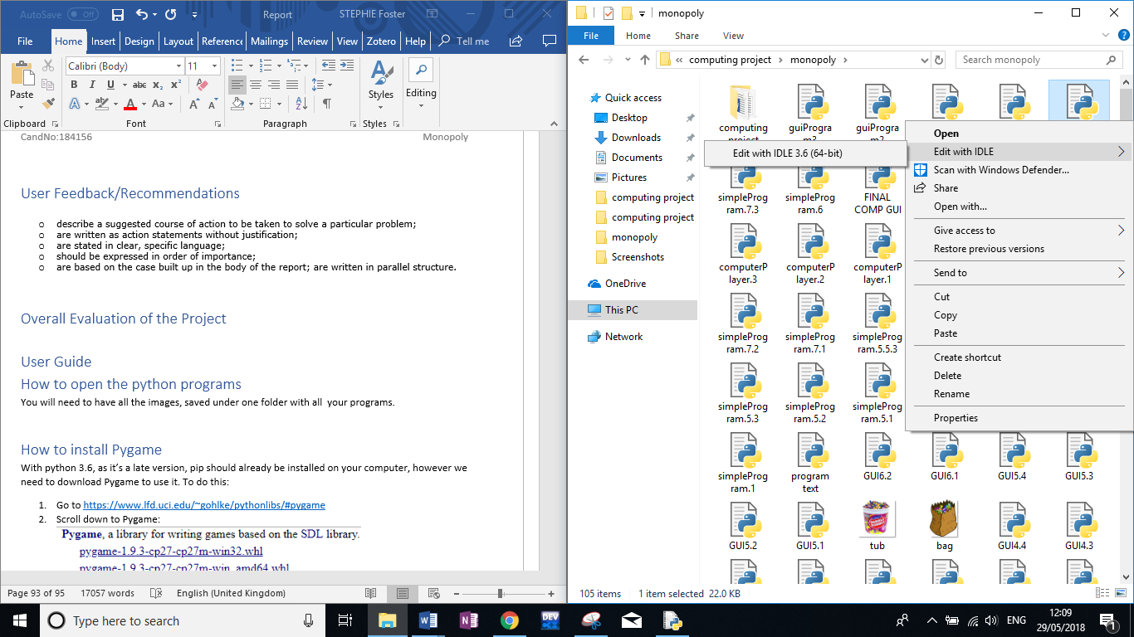

1. To run the module you click on run in the left hand corner then press ‘Run Module’ or press ‘F5’ for a short cut

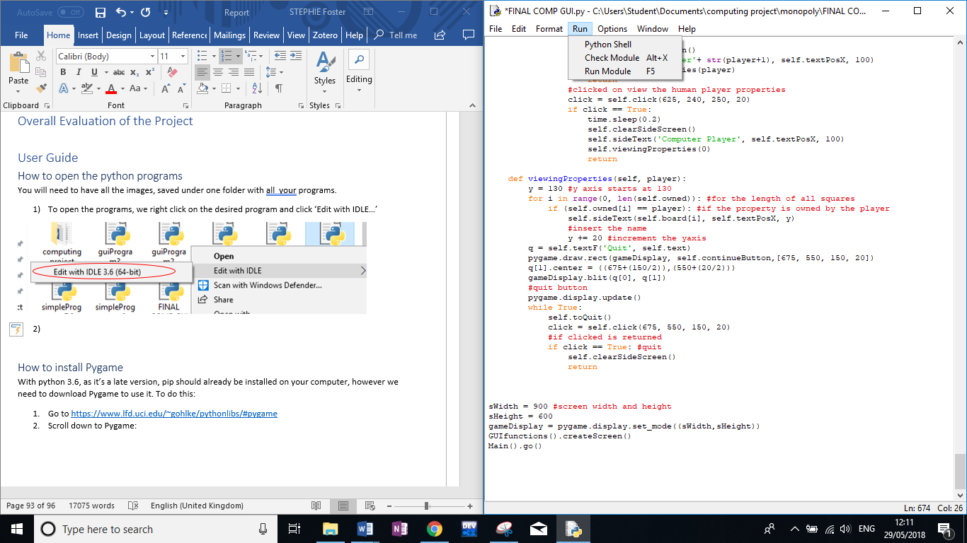

### How to install Pygame

With python 3.6, as it’s a late version, pip should already be installed on your computer, however we need to download Pygame to use it. To do this:

1. Go to <https://www.lfd.uci.edu/~gohlke/pythonlibs/#pygame>
2. Scroll down to Pygame:

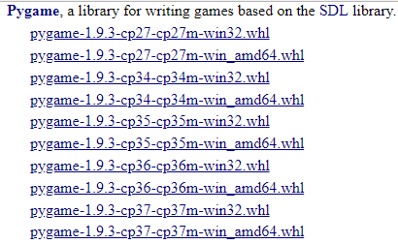

1. And click on the circled link to download if you have a windows computer.
2. Search ‘Python’ on your file explorer, go to the file, then click on ‘Python36’ then ‘Scripts’

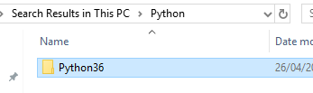

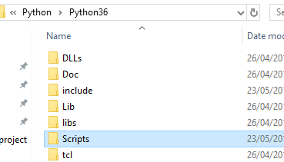

1. Paste the downloaded file into this folder

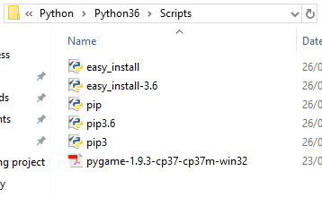

1. Left shift and right click anywhere in the file and the options should appear like below

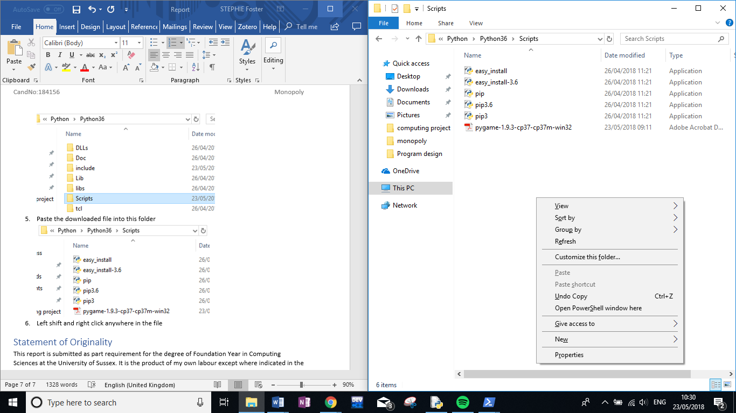

1. Click on ‘Open PowerShell window here’
2. In the shell, enter (case sensitive)
   1. py -3.6 -m pip install Pygame



1. Pygame should then install and at the end of the shell, this message should appear



1. To test if it has been correctly downloaded open up a python shall and enter:
   1. ‘import pygame’
   2. If correct there will be no error message



# References

Python Programming (2014). Game Development in Python 3 with PyGame – 1 – intro [online] Available at: <https://pythonprogramming.net/pygame-python-3-part-1-intro/> [Accessed 25/04/2018]

Stack Overflow (2018). [*How To Install Pygame 1.9.3 for python 3.6*](https://stackoverflow.com/questions/48213358/how-to-install-pygame-1-9-3-for-python-3-6)[online] Available at: <https://stackoverflow.com/questions/48213358/how-to-install-pygame-1-9-3-for-python-3-6> [Accessed 28/03/2018]

Christoph Gohlke (2018). *Unofficial Windows Binaries for Python Extension Packages* [online] Available at: <https://www.lfd.uci.edu/~gohlke/pythonlibs/#pygame> [Accessed 28/03/2018]

# Bibliography

Python Programming. (2014). Introduction to Pygame [online]. Available at: <https://pythonprogramming.net/pygame-python-3-part-1-intro/>

Stack Overflow. 2018. How to install pygame 1.9.3 for python 3.6. [online]. Available at: <https://stackoverflow.com/questions/48213358/how-to-install-pygame-1-9-3-for-python-3-6>

iDroidOS. 2017. How to get Pygame on Python 3.6.1 on Windows/PC!. [online]. Available at: <https://www.youtube.com/watch?v=rkrhLYi3cVo>

Pygame. 2018. [online]. Available at: <https://www.pygame.org/wiki/about>

Craig Oda. 2017. Why Python and Pygame are a great pair for beginning programmers. [online]. Available at: <https://opensource.com/article/17/11/pygame>

Stack Overflow. 2015. How to scale images to screen size in Pygame. [online]. Available at: <https://stackoverflow.com/questions/20002242/how-to-scale-images-to-screen-size-in-pygame>

Webucator. 2015. Python Color Constants Module. [online]. Available at: <https://www.webucator.com/blog/2015/03/python-color-constants-module/>

Stack Overflow. 2012. Correct way to pause Python program. [online]. Available at: <https://stackoverflow.com/questions/11552320/correct-way-to-pause-python-program>

Webucator. 2015. Python Colour Constants module. [online]. Available at: <https://www.webucator.com/blog/2015/03/python-color-constants-module/>

Pygame. Pygame draw. [online]. Available at: <https://www.pygame.org/docs/ref/draw.html#pygame.draw.rect>

Pete Shinners. Help! How Do I Move An Image? [online]. Available at: <https://www.pygame.org/docs/tut/MoveIt.html>

Gigi Sayfran. 2018. Building Games With Python 3 and Pygame: Part 4. [online]. Available at: <https://code.tutsplus.com/tutorials/building-games-with-python-3-and-pygame-part-4--cms-30084>

StackExchange. 2016. Moving around in a 2D grid. [online]. Available at: <https://codereview.stackexchange.com/questions/125286/moving-around-in-a-2d-grid>

Stack Overflow. 2016. How to scale images to screen size in Pygame. [online]. Available at: <https://stackoverflow.com/questions/20002242/how-to-scale-images-to-screen-size-in-pygame>

hakencelik. 2018. What is pygame and how to use it. [online]. Available at: <https://steemit.com/utopian-io/@hakancelik/what-is-pygame-and-how-to-use-it>

Wiki.tcl. 2015. Advantages and Disadvantages of OOP. [online]. Available at: <https://wiki.tcl.tk/13398>

Fandom. 2016. List of Monopoly Properties. [online]. Available at: <http://monopoly.wikia.com/wiki/List_of_Monopoly_Properties>

# Appendix

* GUI = Graphic User Interface
* 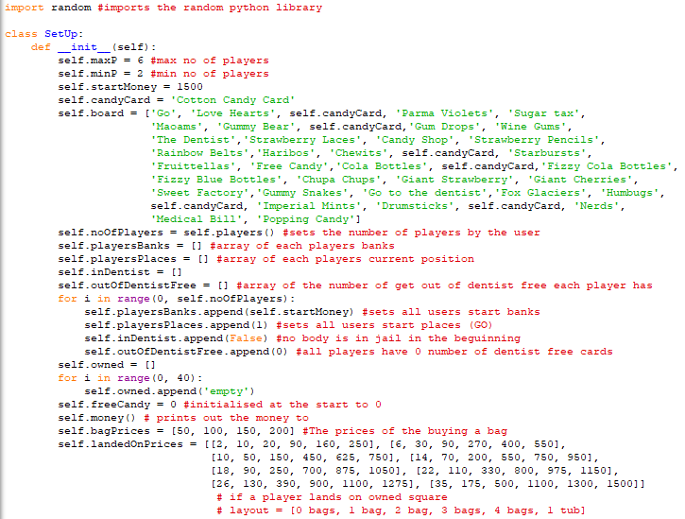Simple Program

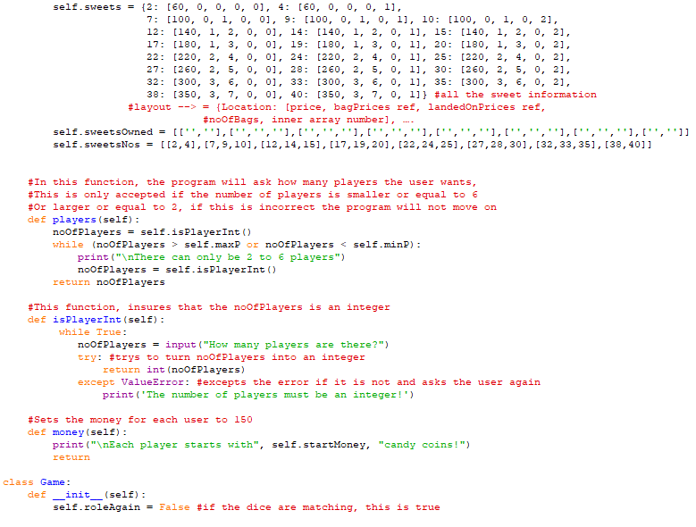 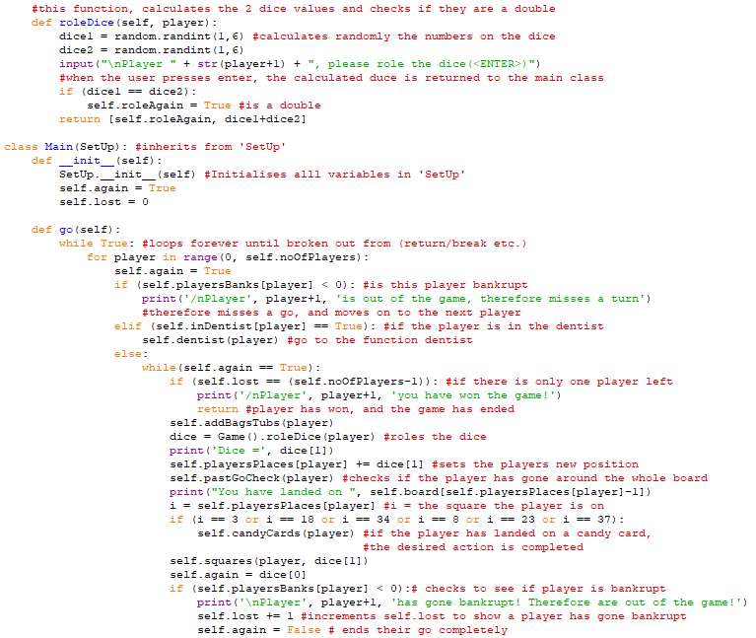 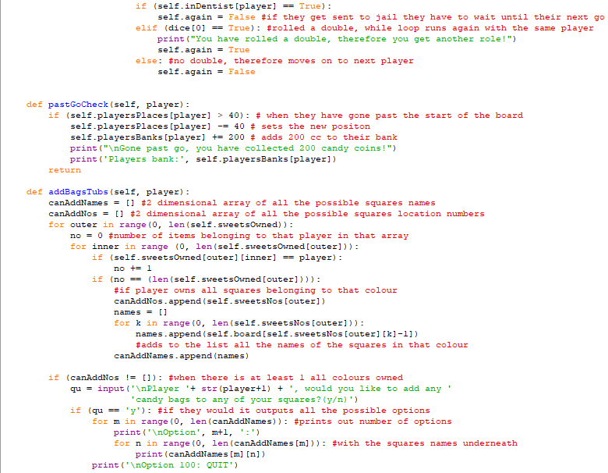

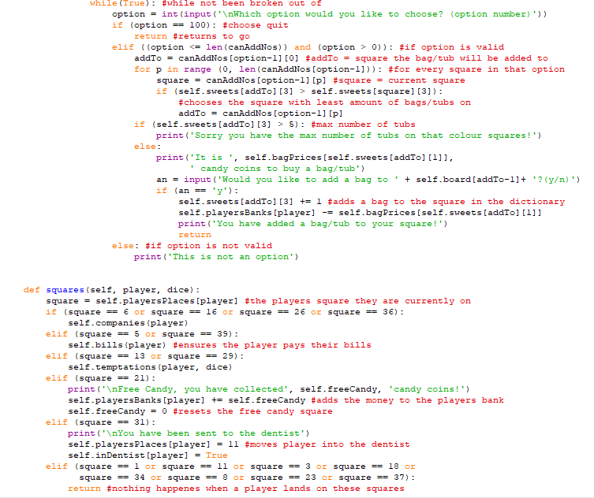

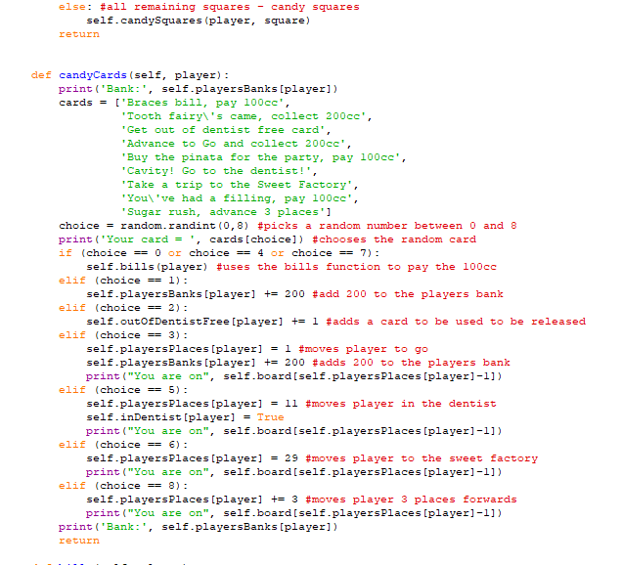

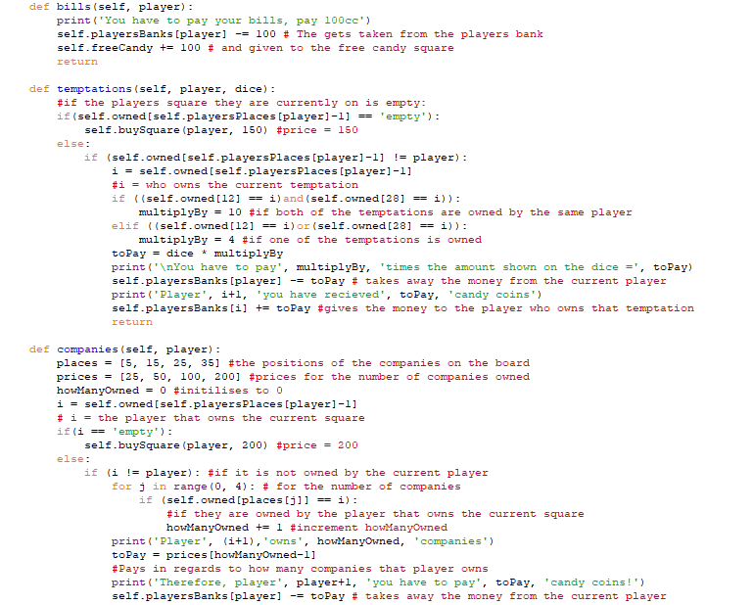 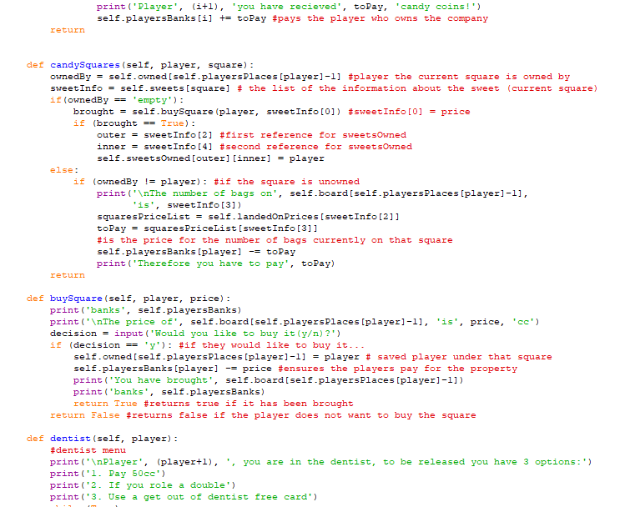

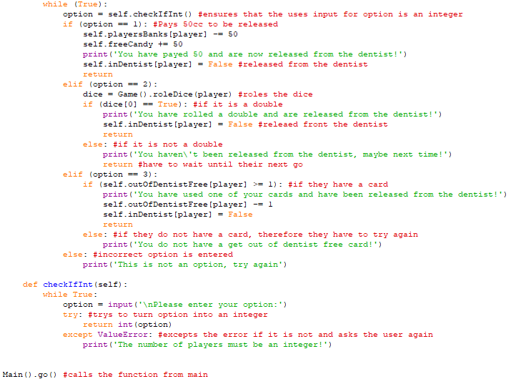

* GUI Program

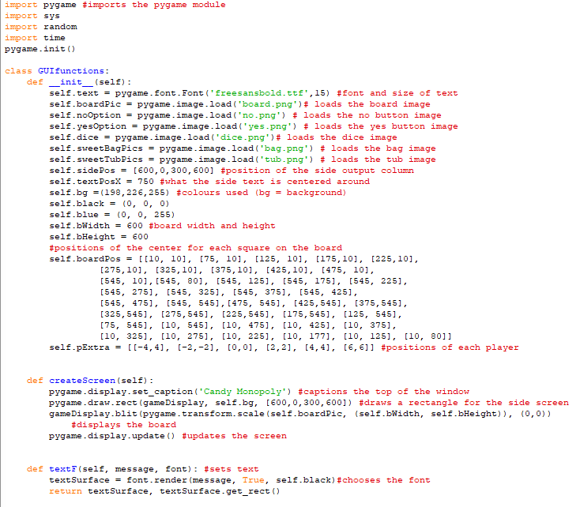

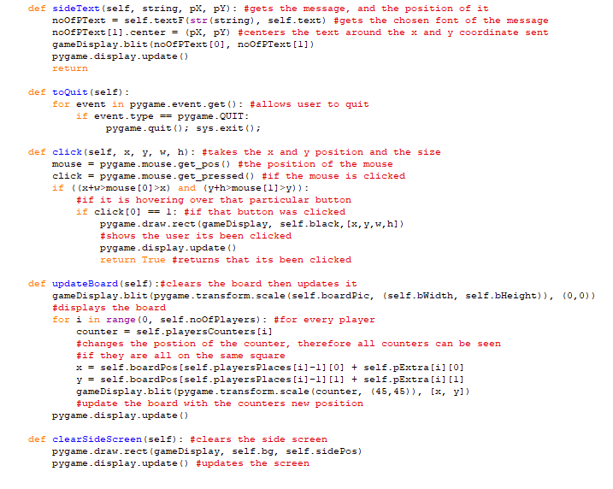

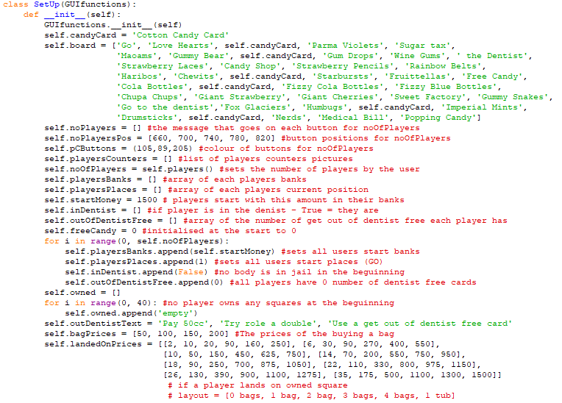

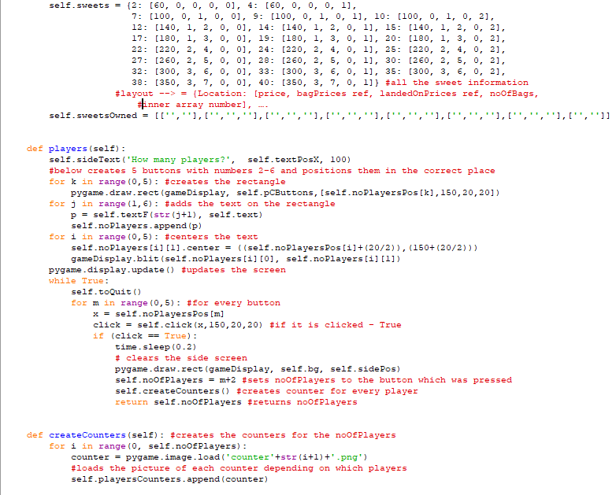

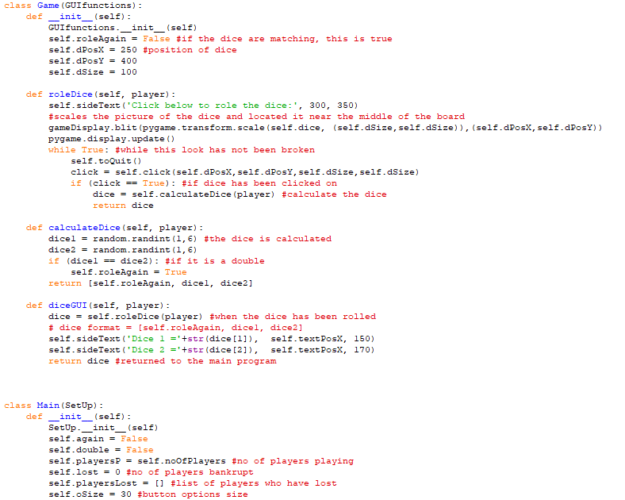

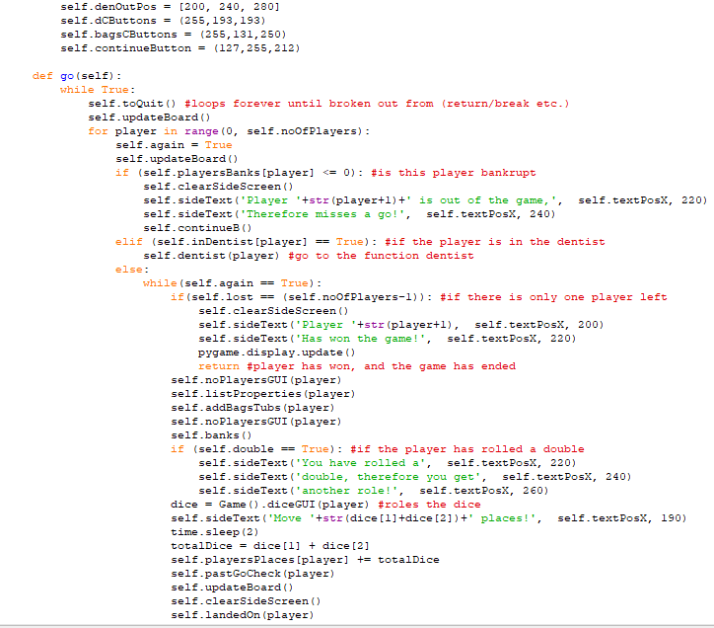

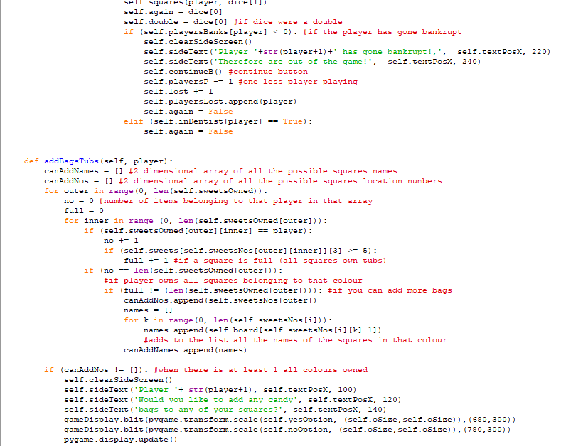

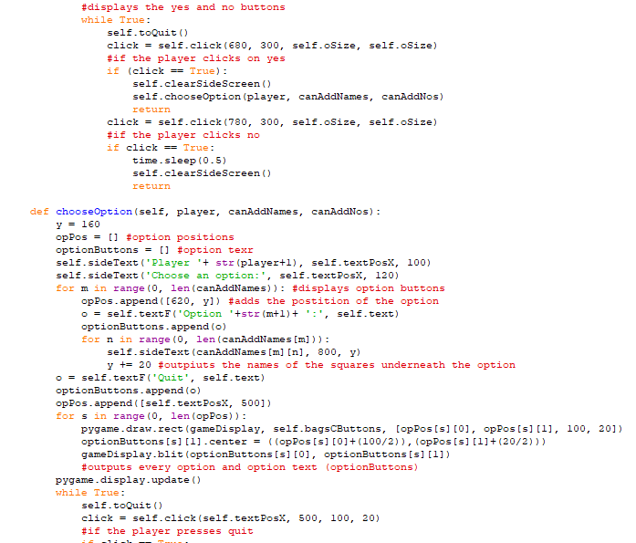

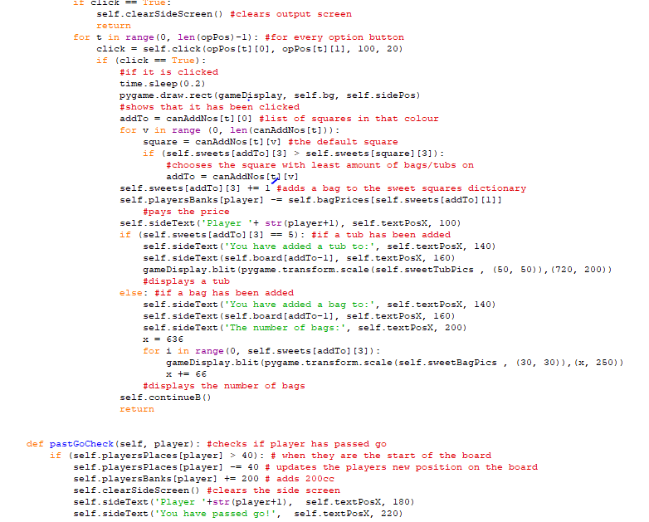

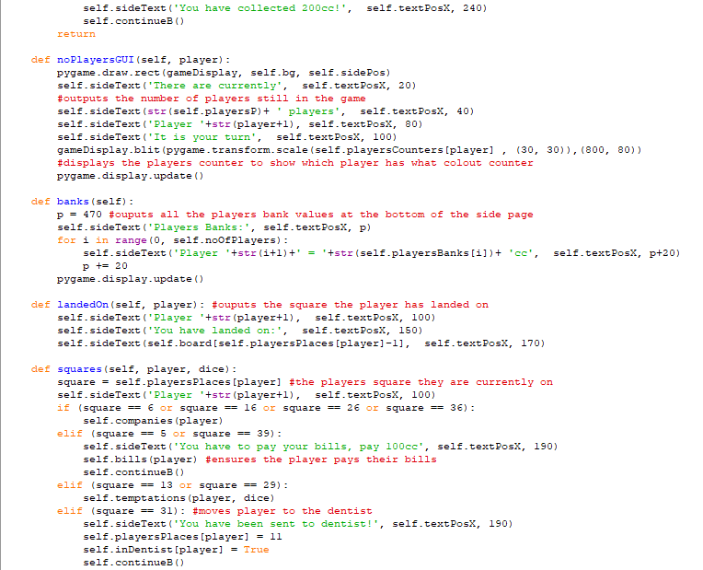

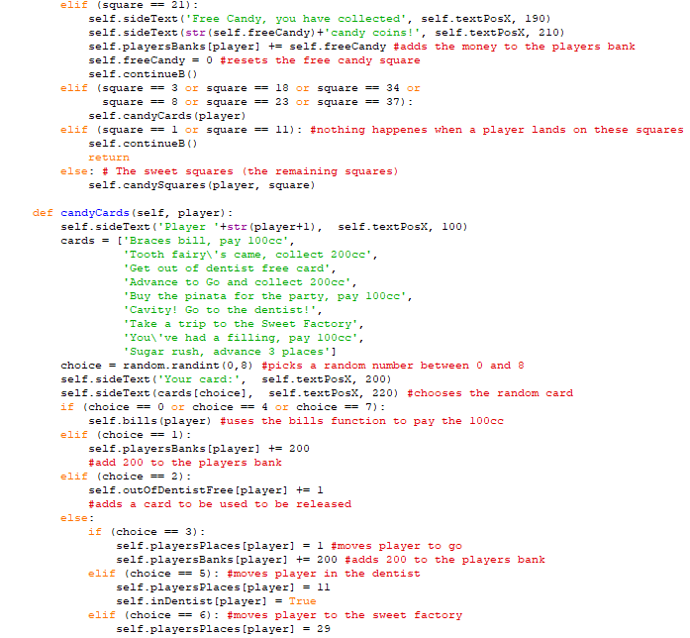

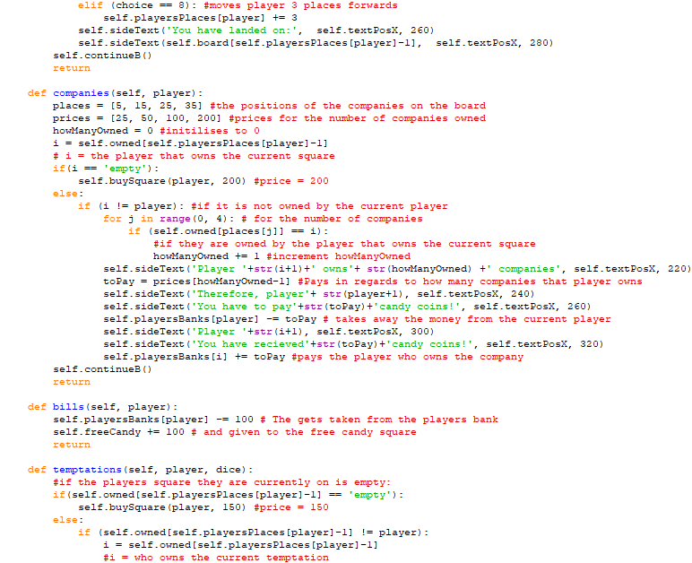

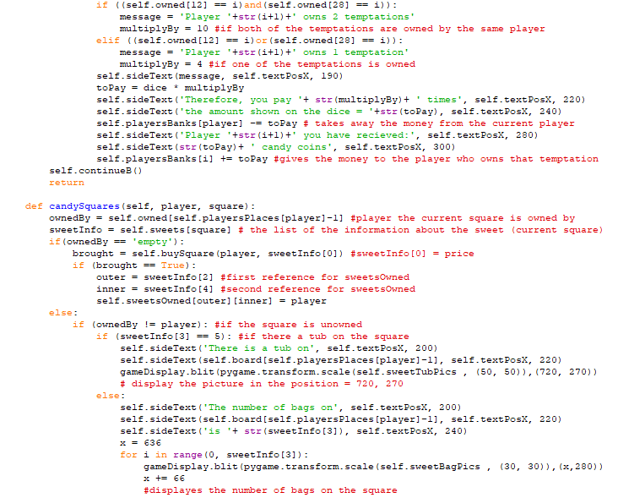

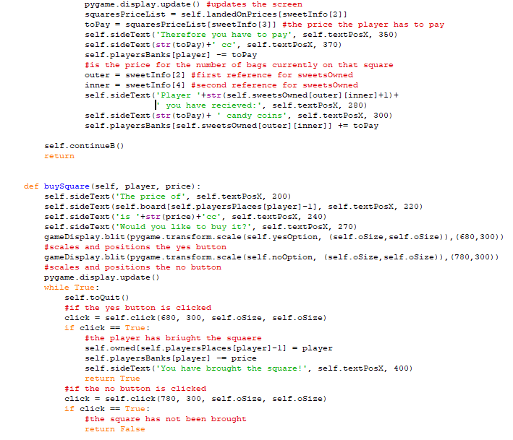

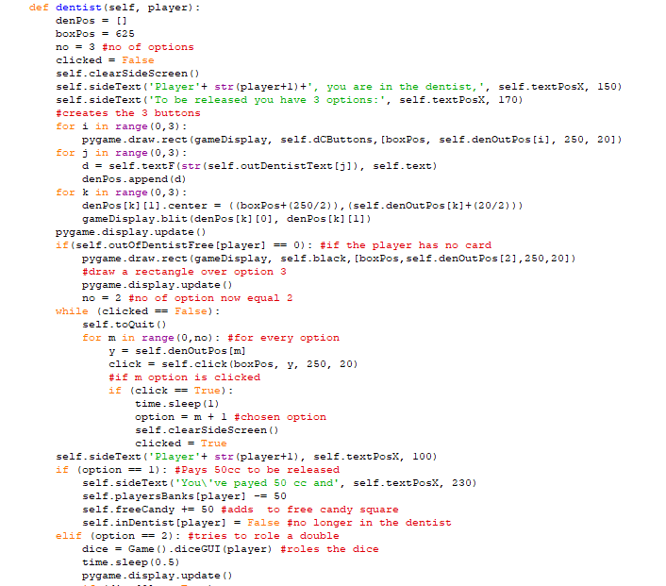

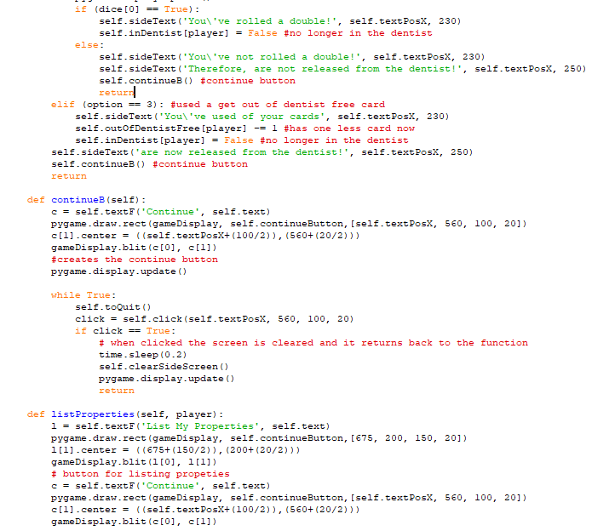

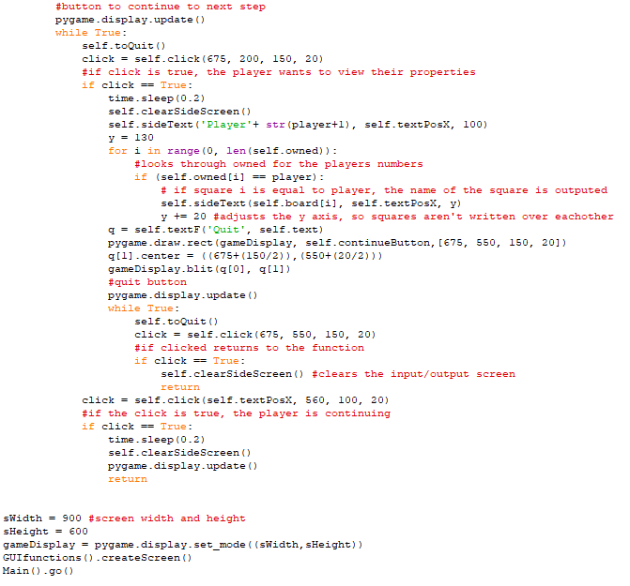

* Computer Player GUI Program

